


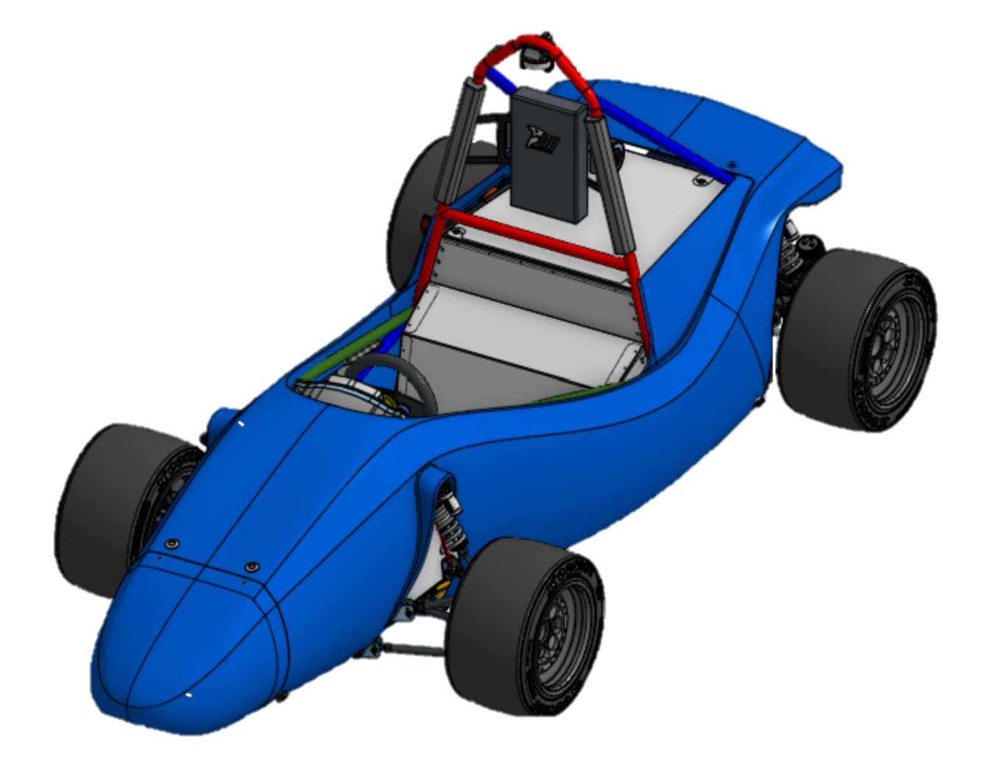
Mechatronic Department Lead Engineer
Directed Reading
NU25
Jacob Lukes
2025

Table of Contents
List of Figures vi
List of Tables vii
1. Abstract 1
2. Introduction 3
2.1. Purpose of This Report 3
2.2. Overview of NU Racing and the FSAE-A Competition 3
2.3. Role of the Mechatronic Department Lead Engineer 3
3. State of the Art 4
3.1. NU24 Tractive System 4
3.2. NU24 Accumulator 4
3.3. NU24 Low Voltage System 5
3.3.1. Low Voltage System 5
3.3.2. Shutdown System 6
3.3.3. Live Telemetry 7
4. NU25 Mechatronic System Architecture 8
4.1. NU25 Tractive System 8
4.2. NU25 Accumulator 8
4.3. NU25 Low Voltage System 9
4.3.1. Low Voltage System 9
4.3.2. Shutdown System 10
4.3.3. Live Telemetry 10
5. Project Scope and Objectives 11
5.1. Original Project Scope 11
5.2. Project Objectives and Success Criteria 11
5.3. Alignment with Team-Level Performance Goals 12
5.3.1. ‘Evolution not revolution’ 12
5.3.2. Validation 13
5.3.3. Reliability 13
5.3.4. Serviceability 14
5.3.5. Self-documenting systems 14
5.3.6. Sustainability 15
5.3.7. Positive team culture 15
6. Project Context and Constraints 16
6.1. Team Structure and Leadership Interfaces 16
6.1.1. Team Structure 16
6.1.2. Leadership Interfaces 16
6.2. Regulatory and Competition Constraints (FSAE-A Rules) 18
6.3. Time, Resource, and Budget Constraints 19
6.3.1. Resource Constraints 19
6.3.2. Budget Constraints 19
6.3.3. Timeline Constraints 20
6.4. Project Dependencies and External Interfaces 20
7. Responsibilities and Management Approach 22
7.1. Technical Responsibilities of the Mechatronic Department Lead 22
7.2. Safety, Compliance, and Quality Assurance Responsibilities 22
7.2.1. Safety-Critical System Oversight 22
7.2.2. Competition Compliance 23
7.2.3. Quality Assurance and Design Review Process 23
7.2.4. Validation Gates and Readiness Criteria 23
7.3. Budget Management and Resource Allocation 24
7.3.1. Budget Management 24
7.3.2. Resource Allocation 24
7.4. Communication and Coordination with Other Departments 25
8. Engineering Decision-Making and Technical Oversight 26
8.1. Systems-Level Engineering Perspective 26
8.2. Design Review and Validation Strategy 26
8.2.1. Design Review 26
8.2.2. Validation Strategy 27
8.3. Key Engineering Decisions and Trade-Off Analyses 28
8.4. Risk-Based Decision Making 28
9. Mechatronic System Development and Integration 30
9.1. Overview of Mechatronic Systems on the Competition Vehicle 30
9.2. Design Evolution and Change Management 30
9.3. Integration with Mechanical and Vehicle-Level Systems 31
9.4. Issues Encountered During System Integration 31
10. Testing, Validation and Compliance 32
10.1. Validation Strategy and Test Philosophy 32
10.2. Simulation and Unit Testing 32
10.3. Integrated Vehicle Testing 33
10.3.1. Orion 2 BMS Data Viewer Software 34
10.4. Technical Inspection Preparation and Outcomes 34
10.4.1. Inspection Strategy and Preparation 36
10.4.2. Accumulator Technical Inspection 38
10.4.3. EV Static, EV Functional and Rain Test 40
10.4.4. Parc fermé 49
11. Team Leadership and Knowledge Transfer 51
11.1. 2025 Mechatronic Team Structure and Member Roles 51
11.1.1. Data Engineer 51
11.1.2. HV Powertrain Engineer 51
11.1.3. Accumulator Electronics Engineer 52
11.1.4. Sem 1 ENGG3200, CEN PCB 52
11.1.5. Sem 1 ENGG3200, PEN & Breakout Board PCBs 52
11.1.6. Sem 2 ENGG3200, HIP, BEN, LVD PCBs 52
11.2. Proposed 2026 Mechatronics Team Structure and Member Roles 52
11.2.1. Data Engineer 52
11.2.2. HV Powertrain Engineer 52
11.2.3. Dynamometer Engineer 52
11.2.4. Accumulator Electronics Engineer 52
11.2.5. Directed Roles 53
11.3. Onboarding, Training, and Mentorship 53
11.3.1. Starter Projects 53
11.3.2. FYP Starter Projects in 2025 54
11.3.3. Lessons Learnt by The Author During the Onboarding, Training and Mentoring Processes 56
11.4. Delegation, Progress Tracking, and Review Processes 56
11.4.1. Delegation 56
11.4.2. Progress Tracking 57
11.4.3. Review Process 57
11.5. Knowledge Transfer and Documentation Outputs 57
12. Risk Management and Lessons Learnt 58
12.1. Technical Risks and Mitigation Strategies 58
12.2. Team and Workload Management Risks 59
12.3. Schedule and Delivery Risks 59
12.4. Key Lessons Learnt 59
13. Project Outcomes and Performance Evaluation 59
13.1. Achievement of Project Objectives 59
13.2. Assessment Against Success Measures 59
13.3. Impact on Team Performance and Competition Readiness 59
13.3.1. Static Events Performance 59
13.3.2. 2025 Dynamic Events Performance 60
14. Reflection and Recommendations 61
14.1. Reflection on the Mechatronic Department Lead Role 62
14.2. Recommendations for Future Mechatronic Leads 62
14.3. Opportunities for Future System Improvement and Innovation 63
15. Conclusion 63
16. References 64
17. Appendices 65
17.1. Appendix A - Email Signature 65
17.3. Appendix B - NU25 Shutdown Circuit 67
17.1. Appendix C - NU25 Electrical System Overview 68
17.2. Appendix D - 2025 Technical Inspection MCHA Bible 69
17.3. Appendix E – 2025 MCHA Systems Design Changes 70

List of Figures
Figure 1. NU25, NU Racing's 2025 Competition Platform 1
Figure 2. NU24's LV Topology 6
Figure 3. NU24 Shutdown Circuit 7
Figure 4. NU25 Shutdown Circuit 10
Figure 5. NU Racing Team Structure 17
Figure 6. Dyno Progress Meeting Excel Snippet 17
Figure 7. Instructions to Find FSAE-A Rules 18
Figure 8. Example of Budget Summary 24
Figure 9. Example of Budget Spending Delta 24
Figure 10. Whiteboard Change Management Solution 31
Figure 11. HIP V1.4 Unit Test Checklist 33
Figure 12. 2025 Technical Inspection Award 35
Figure 13. Thermal strip viewing hatch 38
Figure 14. Accumulator Technical Inspection Fail Point 1 40
Figure 15. Accumulator Technical Inspection Fail Point 2 40
Figure 16. Visualisation of where phase cable securing is needed 41
Figure 17. Location of MSD bolts that should be positively locked 42
Figure 18. Showing 100 mm proximity grounding requirement in EV Static 43
Figure 19. Seatbelt harness holder locations 44
Figure 20. A) shows location of BOTS in Pedal Box. B) describes reason for continual breaks 45
Figure 21. CEN fuse that was blowing during EV Functional Mock Technical Inspections 46
Figure 22. FT.5.2 Explanation 46
Figure 23. Non-compliant IMD Resistor Box 47
Figure 24. Compliant IMD Test Resistor Box 48
Figure 25. Proof of IMD Test Resistor Power Requirement Compliance 49
Figure 26. From left to right, Zak Lobko (Sem 1 Directed Reading), Samuel Connett (HV Powertrain), Oscar Rudman (Accumulator Electronics), the Author, Jayden Horvath (Autonomous Vehicle Development), Oliver Bunny (Data Engineer), Jayson Mills (Sem 1 Directed Reading), seated in car Mia Cosentino (Sem 2 Directed Reading), and Fletcher Cogoi (not pictured) 51
Figure 27. 2025 Acceleration Faults 61

List of Tables
No table of figures entries found.

Abstract
NU Racing is the Formula Society of Automotive Engineers – Australasia (FSAE-A) team from the University of Newcastle. 2025 saw the design, manufacture and commission of NU25, a single seat electric vehicle, which participated in the 2025 Formula SAE-A competition in Calder Park, Melbourne.
Building upon the overall finish of 4th place in 2024, NU Racing pushed for a reliable and traction limited vehicle, while also improving data collection methods and maintaining a similar weight to NU24. The team maintained a ‘build first, design second’ philosophy, adopted from previous years due to the team’s small member count and low budget. Alongside this, NU Racing changed to a dual cycle development approach, allowing for time to be spent on projects for future NU Racing cars. Projects included designs for a Pouch Cell Accumulator, a Monocoque Chassis, Hub Motor Gearboxes, and AVONE.
NU Racing achieved 3rd place in the 2025 FSAE-A competition, the highest the team has ever achieved since it started in 2002.
The 2025 leadership team was made up of the Team Leader, Cooper Chomicki, the Chief Engineer, Alec Chapman, the Mechanical Department Lead Engineer, Cameron Higgins, and the Mechatronic Department Lead Engineer, the author.
Technical Inspection is vital to ensure compliance with the FSAE-A ruleset and safety during the competition. Due to the extensive work from 2023 and 2024, as well as many mock inspections and preparation in 2025, NU25 passed EV Static Technical Inspection first try, Accumulator Technical Inspection second try, and EV Functional Technical Inspection first try. Both Technical Inspection and Parc fermé at the 2025 competition was extremely smooth and successful, which lead to the team receiving the Technical Inspection Specialty Award.
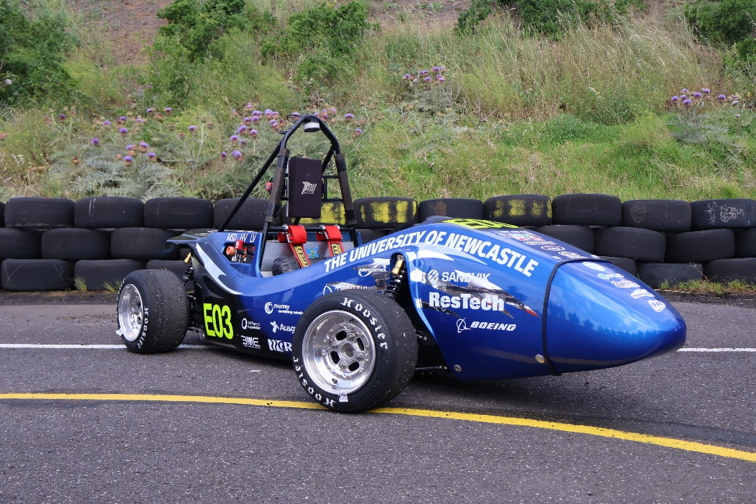
Figure 1. NU25, NU Racing's 2025 Competition Platform

Introduce the system that this report details. Aim for 3-5 pages. Include pictures. A top-level description of the system and report.
- A good way to start is “This report details the design, manufacture and commissioning of the X system for EV.Three.”
- What is this system and what does it do?
- For the purpose of this report, what does this system entail/include and what is out of scope? Where should people go to learn about out of scope but connected things?
- What are they key features and specifications of this/the EV.Three system? Especially compared to other years/teams/automotive applications/etc.
- How was the system manufacutred? How did the design evolve over the development cycle/did substantial changes have to be made?
- What was the final performance of the system at the competition?

Introduction
2025 was the year for validation and reliability, two areas that were identified as weak points for the team in 2024. 2025 saw a 25% budget cut from 2024, with increased Final Year Project (FYP), Directed Reading and Extra Curricular member counts. The team was asked to do more with less, which was a struggle at times, but due to the comradery of the team members, the team pulled through, resulting in a very successful year both technically and socially.

Purpose of This Report
This report details the role of the Mechatronic Department Lead Engineer, their responsibilities, goals, constraints and decisions. It includes the combined work of the author from the 27th of January 2025 to the 14th of December 2025, amounting to 1,531 hours of time and effort. It also incorporates a technical overview of NU25 with respect to the electrical systems, recommendations and advice for future Mechatronic Department Lead Engineers. As well as overall performance of the Mechatronic team during the year and at the 2025 FSAE-A competition.

Overview of NU Racing and the FSAE-A Competition
Due to NU Racing’s small team size, its success is largely reliant on the hard work, determination, and the special chemistry that the team creates, as well as the support from the University’s valued staff members.
Formula Society of Automotive Engineers – Australasia (FSAE-A) is a student design competition where university teams design, build and race small formula-style open-wheel race cars. The purpose is for students to gain real-world engineering and project management experience. [1]
*TODO: explain how it is split into static events (and what they are) and dynamic events (and what they are), the role of ESOs (at least one present with accumulator at all times) and the main ESO (turning on the car at dynamic events, present for all EV tech inspections (accu, static functional, parc ferme), accumulator clean rooms, charging stations, pits (set up, packing), celebration ceremony, photo??, bump in (energy meter, pit setup)*

Role of the Mechatronic Department Lead Engineer
The Mechatronic Department Lead Engineer aims to bridge the gap between high level overarching team goals and the work that must be done to achieve these goals. The role operates within constraints set by the Team Leader and Chief Engineer, ensuring consistent communication with the Mechanical Department Leader and effective collaboration with members of the Mechatronic team.
The Department Lead is responsible for monitoring technical performance, member wellbeing, budget usage, and the safety and quality of the team’s work. Additional key duties include ensuring compliance with competition rules, technical inspection requirements, accuracy of Mechatronic components in the cost report, overseeing correct validation of designs, and maintaining high standards in all Mechatronic systems.
Through the integration of management oversight with technical guidance, the role ensures that departmental output consistently supports the team’s overall performance goals.

State of the Art
NU24 was built in 2024 by NU Racing. It completed 372 km of testing and was an extremely competitive vehicle to be given.

NU24 Tractive System
The car’s power train featured a 7.2 kWh 453.6 V Accumulator, capable of discharging 180 A, a 124 kW EMRAX 228 MV AC Motor, a Cascadia CM200DX inverter. The inverter allowed for regenerative braking, which Joshua Hayward implemented during 2024 and resulted in 0.92 kWh to be regenerated during the 2024 Endurance, scoring the team 4th place in the efficiency event.
To protect the cells from being over discharged or charged when at a low or high State of Charge (SOC), dynamic current limiting was implemented by Joshua Hayward in 2024, more information can be found in his FYP report [2], available on the NU Team’s SharePoint.
*TODO: ADD INFO ON BROKEN MC NOT BEING BROKEN*
*TODO: IMAGE OF SIDE VIEW OF NU24 WITH ACCU, MOTOR AND MC HIGHLIGHTED*

NU24 Accumulator
The Accumulator is comprised of 108 ENEPAC Li1x6pVTC6 modules (one module consists of 6 18650 cells connected in parallel) connected in series, monitored by an Orion BMS2 and the team’s own temperature monitoring device, the CANaMON, a PCB which converts Analogue temperatures onto the CAN BUS. It also features the Low Voltage Distribution board (LVD), Precharge Board and Insulation Monitoring Device, the BENDER ISOMETER IR155-3203.
*TODO: TWO PART IMAGE OF NU24 ACCU SHOWING CELLS, SEGMENTS, TOP PLATE, ALL LABELLED*

NU24 Low Voltage System

Low Voltage System
The low voltage (LV) system on NU24 had a nominal voltage of 12 V, supplied from a LH4LK motorcycle battery, and a TDC-IY-320-12 454 V to 12 V DCDC. A distributed topology of multiple individual nodes with Teensy 4.0 microcontrollers positioned across the car was used. Overview shown in Figure 2. NU24's LV Topology. List of nodes included:
- The Pedal Electronic Node (PEN): Monitors the Brake Pressure Sensors, Accelerator Pedal Position Sensors (APPS), and Brake Over Travel Switch (BOTS). Work conducted by Eliza O’Donnell.
- The Dash Electronic Node (DEN): Monitors the Dash E-Stop and Ready-To-Drive (RTD) button, MoTeC connection, MoTeC button and relays PEN signals. Work conducted by Jackson Boustany, more information can be found in his FYP report [3] available in the NU Team’s SharePoint.
- The Central Electronic Node (CEN): Monitors the Hard Fault Latch (HFL) breakout board, Top E-Stops, Brake System Plausibility Device (BSPD) breakout board, OK High Signals (OKHS), Cooling and brake light switching, sounder and LV Power distribution. Work on the CEN Motherboard was conducted by the author, more information can be found in the ENGG3200 report [4] also created by the author in the NU Team’s SharePoint. Information on the HFL and BSPD breakout boards can be found in Jacob Bush’s ENGG4200 report [5], available in the NU Teams SharePoint.
- The Human Interface Panel (HIP): Switches on LV Power, Tractive System Master Switch (TSMS), HV Disconnect (HVD) Interlock, Test Points and Tractive System Active Light (TSAL) and Discharge Relay Breakout board. (This board also is HV). Work was conducted by Marisa Mclean.
- Low Voltage Distribution (LVD): Relays Power to the Accumulator Fans and Communicates Accumulator Temperatures from the Battery Monitor System (BMS) to the CEN as well as BMS OKHS. (This board also is HV). Work conducted by Daniel Iveson, more information can be found in his FYP report [6], available on the NU Team’s SharePoint.
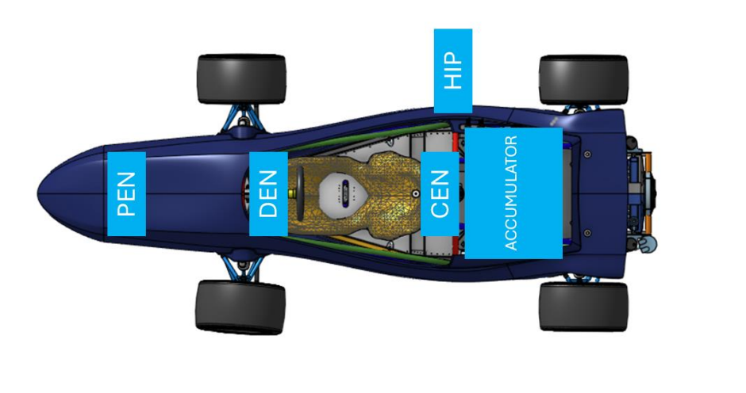
Figure 2. NU24's LV Topology
Once completely tested, this system was reliable, apart from the issue that stopped the car during the second driver stint of Auto X during the 2024 competition, detailed explanation found in the Testing, Validation and Compliance section.

Shutdown System
The shutdown circuit is the car’s safety signal; it is a 12 V digital on-off signal that passes through many checkpoints through-out the car. It is designed to keep the driver, individuals nearby the car and the car’s components safe in the case of an emergency or fault. When all checkpoints are good, the car is allowed to switch into High Voltage (HV). If something trips the circuit, the car will exit HV and depending on the fault, cannot be reactivated by the driver until the car is power cycled (Low Voltage (LV) is turned off as well). NU24’s shutdown circuit is depicted in Figure 3. NU24 Shutdown Circuit. A high-resolution version can be found in the Racing-NU24 Github Repository.
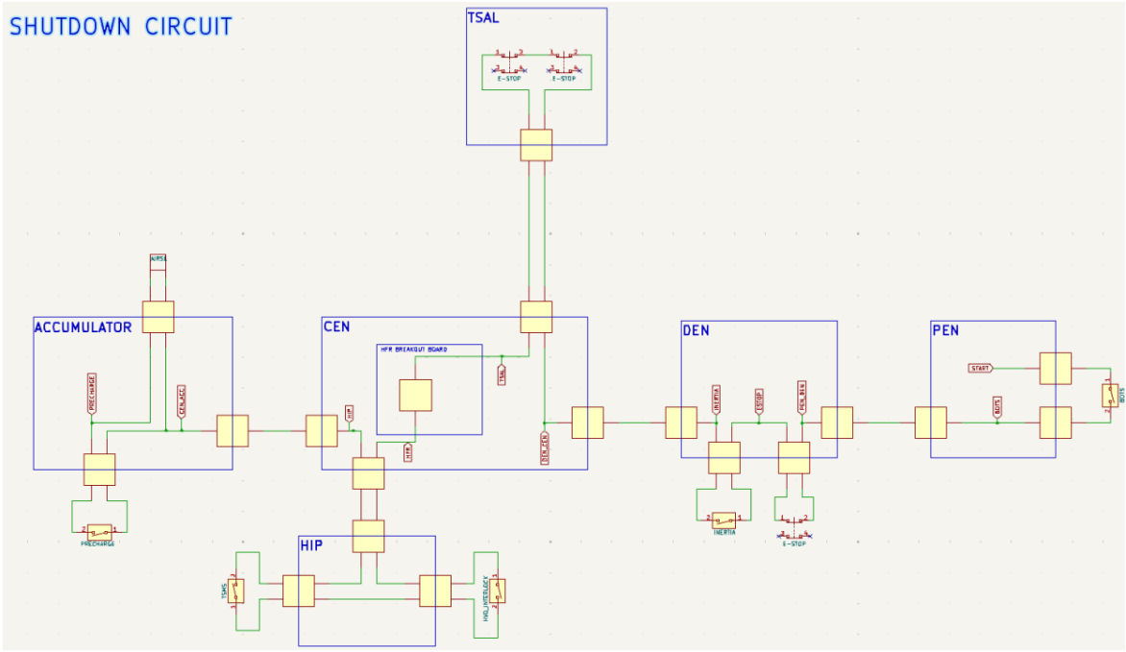
Figure 3. NU24 Shutdown Circuit

Live Telemetry
The Dash Electronic Node (DEN) housed the MoTeC C125 Dash, a datalogger that is used to read all desired signals on the car. It logs its data in high resolution for collection after the vehicle has run. This is done by connecting a RJ45 cable to the access point on the DEN. Paired with a Parani SD1000, the dash can transmit its data live, at a reduced resolution. The dash and data logging was implemented by Robert Stanley in 2023 and has saved many hours of fault finding, as well as effectively highlighting bottlenecks in the vehicles electrical system, allowing for informed data driven decisions to be made.

NU25 Mechatronic System Architecture
The biggest change for NU25 was the implementation of a Limited Slip Differential (LSD), which would allow for efficient cornering at low to medium speeds and increased drivability when driving at the limit of the car. Due to this large change and to try and give as much testing time as possible for this differential, as well as other vehicle dynamic tests, it was decided to keep the Mechatronic system changes to a minimum.

NU25 Tractive System
Aligning with the minimal system changes NU25 kept the same 7.2 kWh 453.6 V Accumulator, Cascadia CM200DX inverter, and 124 kW EMRAX 228 MV AC Motor. Samuel Connett built upon Josh Hayward’s multivariable current limiting in 2025; by including both cell temperature and voltage limits, the car would successfully not allow the driver to request high current during periods of high cell temperatures and cell voltages outside of their limits. More information can be found in Samuel Connett’s FYP report [7], available on the NU Team’s SharePoint.
*TODO: IMAGE OF SIDE VIEW OF NU25 WITH ACCU, MOTOR AND MC HIGHLIGHTED*

NU25 Accumulator
NU25 kept the same cell arrangement as NU24’s Accumulator. Improvements in weight reduction were gained by changing:
- Accumulator insulating material from FR4 to Nomex paper
- Top plate material from GPO3 to PEEK
- Segment housing material from FR4 to a PC/ABS 3D printed material
More information can be found in Ryan Bird’s FYP report [8], available on the NU Team’s SharePoint. Serviceability of the Accumulator also increased with the implementation of the new PEEK top plate, due to a rearrangement of the components, allowing the Precharge Teensy 4.0 programming port and the BMS wire harnesses to be in a more accessible location.
*TODO: TWO PART IMAGE OF NU25 ACCU SHOWING SEGMENTS AND TOP PLATE CHANGES, ALL LABELLED*

NU25 Low Voltage System

Low Voltage System
NU25’s LV system maintained the same 12 V nominal voltage battery and DCDC, with the same distributed topology of multiple individual nodes using Teensy 4.0 microcontrollers. These nodes maintained largely the same functionality, changes include:
- The Pedal Electronic Node (PEN): Rearrangement of components, increasing fault finding ability when bench testing and suppressing potential noise on sensor inputs. Work was conducted by Jayson Mills, more information can be found in his ENGG3200 report [9], available on the NU Team’s SharePoint.
- The Dash Electronic Node (DEN): No changes.
- The Central Electronic Node (CEN): Changed mounting location to be opposite the Human Interface Panel (HIP) on the chassis. This significantly increased the serviceability of the node and moved it away from the high switching noise of the inverter and DCDC. Work was conducted by Zak Lobko, more information can be found in his ENGG3200 report [10], available on the NU Team’s SharePoint.
- The Human Interface Panel (HIP): Saw improvements to reliability and rules compliance. Higher quality switches were used for the Grounded Low Voltage (GLV) and Tractive System (TS) master switches. Different HV connectors with dedicated interlock contacts were used, as well as other component changes. Work was conducted by Mia Cosentino, more information can be found in her ENGG3200 report [11], available on the NU Team’s SharePoint.
- Low Voltage Distribution (LVD): Saw improvements to both reliability and serviceability. By implementing a double switching MOSFET circuit from the NU Teams Standard Circuits, previous cooling concerns of the board were completely negated. NU24’s LVD had a large 24 pin MOLEX connector to interface with the Precharge, Isolation Relays, BMS and IMD, it effectively reduced the part count of the board but over time the connector became harder to disconnect from the board, which significantly impacted the serviceability of the Accumulator. This was replaced with a dedicated MOLEX connector for each interface (Precharge, BMS, etc), minimising the time it took to service the Accumulator. Work was conducted by Oscar Rudman, more information can be found in his FYP report [12], available on the NU Team’s SharePoint.

Shutdown System
NU25 kept a similar shutdown circuit to NU24. Notable changes being the increased number of interlocks on the HIP with the introduction of HV connectors with dedicated interlock lines, as well as moving the interpose relay from the LVD to the CEN, making it more accessible. Depicted in Figure 4. NU25 Shutdown Circuit. A high-resolution version can be found on the NU Teams SharePoint, Racing-NU25 Github Repository, and in Appendix B - NU25 Shutdown Circuit.
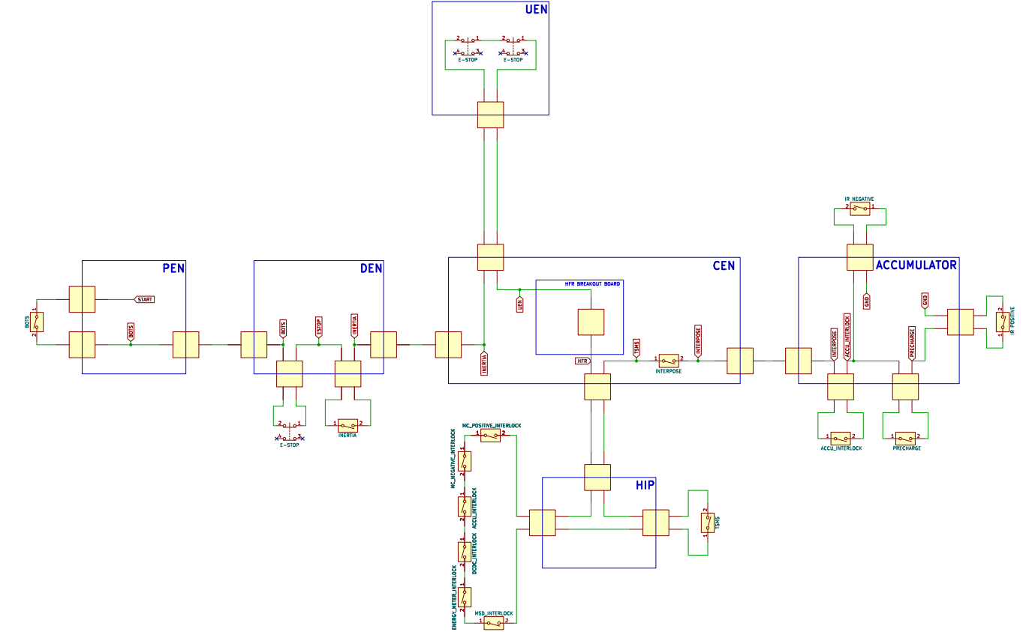
Figure 4. NU25 Shutdown Circuit

Live Telemetry
Due to the high reliability and robustness of NU24’s live telemetry system, NU25 saw no changes to it.
The only drawback to the current solution is that there is a large learning curve to using the proprietary software required. Thus, a Zero-To-Hero style document was created by the author, with contributions from Jayson Mills, to aid in learning the software. It can be found in SharePoint called ‘MoTeC Zero-To-Hero’, as well as in the Appendix of this report. At the time of writing it has yet to be finished, readers who are interested are encouraged to contribute to the Zero-To-Hero.
*TODO: ADD MOTEC ZERO TO HERO TO APPENDIX, AND TRY AND FINISH IT AND UPDATE ABOVE TEXT*

Project Scope and Objectives

Original Project Scope
After the role began halfway through 2023, the Mechatronic Department Lead Engineer role has had time to develop and evolve into what it is today. Due to this, the original scope set at the beginning of 2025 for the author did not change much during the year. Just the wording and definitions required to encapsulate the work done in this role were edited and revised during the year.
The scope of work was set out as:
- Working with the constraints set by the Team Leader and Chief Engineer
- Working with the Mechanical Department Lead
- Participating and/or leading Industry Partner Visits
- The delegation and management of mechatronic scopes and projects in collaboration with Team Lead
- The Mechatronic Budget
- All the mechatronic components used in the team
- Competition documents (ESF, ESO/ESA)
- The mechatronic aspects of the Cost Report, Design Event and Technical Inspection
- Regular Track Day Attendance
- Mechatronic Testing
- Management of NU Racing stock count
- Mechatronic Performance at Competition
- Mechatronic Safety at Competition
Additions to scope of work
- Technical knowledge of the Mechatronics team
- Maintaining regular engagement with all Mechatronic team members, both on technical matters and team wellbeing
- Vibes of the Mechatronics team
- Junior involvement in the Mechatronics team

Project Objectives and Success Criteria
During creation of a ENGG4200 - NU-Teams-Project-Scope-Form, the following objectives and success criteria were identified:
- Team passes Accumulator, EV Static, EV Functional and Rain Test Inspections
- All new MCHA system designs validated
- Efficient knowledge transfer of processes and systems
- Well-structured information regarding systems on the competition platform, for current and future team member’s access
- Documented tasks completed by MCHA team
- Training and advice provided to MCHA team
- Suggested areas the MCHA team can innovate/improve in

Alignment with Team-Level Performance Goals
Team-level goals for 2025 included:
- Evolution not revolution
- Validation
- Reliability
- Serviceability
- Self-documenting systems
- Sustainability
- Positive team culture
The following decisions and system changes were made to align with these goals. The guiding philosophy for technical change was to implement changes only when supported by data demonstrating a clear need. This approach reduced the risk of introducing changes for their own sake, a consideration that strongly informed the author’s decision-making process. Limiting modifications also enabled increased track testing time, as the changes implemented were minor and involved well-understood systems.

‘Evolution not revolution’
  - PEN: The main changes were to the layout and noise suppression on sensor inputs, all other circuits had been tested in previous years, remaining in line with an evolution.
  - CEN: All circuit topologies remained the same, with the addition of the interpose circuit that was previously used and tested on the LVD in 2024. The main change for the board was that it was moved to opposite the HIP, which the author believes to be an evolution instead of a revolution, as all circuit topologies had remained the same, only the location of the board on the car. With the idea that as many aspects as possible were kept the same.
  - HIP: Changing the HV connectors to ones with dedicated interlock lines was seen as a potentially risky change and a revolution instead of an evolution, due to using connectors the team had not previously used. But it was decided to go with them since the alternative to remain compliant with the rules was to use external 3D printed enclosures to cover the detaching clips on the connectors, which was a time consuming and demanding task to do whenever the connectors were to be taken off.

Validation
  - Validation was implemented at every step of the PCB creation process, from LTspice simulations, bench testing circuits before PCBs were ordered, and extensive bench testing of PCBs once they arrived and were manufactured. This significantly reduced the number of unknown issues arising during integration of new Mechatronic systems.
  - The Expansion Board saw substantial success in 2025, with work completed by Oliver Bunny, in-depth information can be found in his FYP report [13], available on the NU Teams SharePoint. A summary of the project includes, the board elegantly implemented wheel speed sensors, brake temperature sensors, wheel temperature sensors, and shock potentiometer sensors on all four wheels, steering angle sensor, radiator temperature sensors and strain gauges all into the car’s existing CAN Bus system, allowing it to be read and logged on i2 Pro. Each sensor circuit was extensively bench tested before integration with the car and allowed for many other FYP students to get critical data to show both improvements and gain validation of their decisions with their projects. One example was obtaining brake temperature data from all four wheels, which allowed Jethro Raj to conclude that the brake pads that the team uses on the front wheels are insufficient for how temperature range of the front wheels get. More information can be found in Jethro Raj’s report [14] on the NU Teams SharePoint.

Reliability
  - CEN: The new position meant that it was above shielded HV wires, and out of the way of noise from the inverter and DCDC, resulting in no issues being caused from noise on the CEN during the testing of NU25. With appropriate fuse sizing, the system became more reliable as fuses would no longer blow frequently during normal operation. The only downside to this change was the increased distance that the analogue output from the current sensor in the HIP would have to travel to get to the BSPD. This downside was avoided by using separate shielded cable for this signal within the CEN to HIP loom.

Serviceability
  - CEN: The new position and enclosure design made it far quicker and easier to get to when issues arose, being four bolts to lift off the lid and access all components, as opposed to six bolts and two hard to get to zip ties.
  - LVD: All surface mount and through-hole components (apart from the DT connectors) were placed on the opposite side to the DT connectors, allowing for quick fault finding and probing when issues arose during testing.

Self-documenting systems
  - Self-documenting systems refers to a design aspect for a system. It is the idea of explaining as much as possible to a user through physical aspects about the design.
  - Examples include having name plates on all PCBs with the name of the creator, year and month, version number, and car that it was used on. Or having a detailed schematic for a PCB that is as simple as possible, with minimal spaghetti traces and all signal names labelled with easy-to-understand names. Or within code sets for PCBs, having simple variable names, separating long lengths of code into their own functions, commenting (shock horror) out blocks of potentially confusing code. If ever in doubt, ask another team member to check over your work and see if they can understand it without you having to explain it to them. If there is anything they get confused about, it is on you as the ‘transmitter’ to provide more explanation in the design.
  - NU Racing successfully implemented this goal in 2023, with improvements in 2024. Thus in 2025, not much had to be changed for this, only to maintain what had already been set out.

Sustainability
  - Being a goal that is not directly related to systems on the car, the author interpreted this goal as writing down and creating as much knowledge transfer documents as possible during the year. The documents came in the form of Zero-To-Hero style documents aimed at individuals who are familiar with NU Racing already. Alongside these documents, an in-depth KiCad schematic detailing the Mechatronic system layout of the car, with all associated signals and connections, called the ‘Electrical System Overview’ was created. These documents are talked about in detail in the Knowledge Transfer and Documentation Outputs section of this report.
  - On-boarding and upskilling the next generation of NU Racing leaders as early as possible significantly helps with knowledge transfer. Being an overarching team goal, the author contributed to this by upskilling Jayson Mills, the next Mechatronics Department Lead Engineer subtly during the year, then once he was officially announced for the role late October 2025, giving more in-depth advice and including him in decisions that were made towards the end of 2025. It is recommended that in future years a similar process is followed, if not officially chosen as the next lead within the year, at least give directed advice to an individual who enjoys the team and shows initiative in learning the Mechatronics systems of the car.

Positive team culture
  - Being another non-technical goal, as well as a potentially hard to measure for success goal, the author approached this by creating bonds with team members, learning about their lives outside of NU Racing. As well as attempting to try to break down social barriers between members.
  - From the point of view of well-being management, checking in with members in a non-technical sense to see if they needed breaks in workload. If larger issues came up, that were out of the scope of help that the author could provide, forwarding the information up the organisational chart.
  - The author found this easiest to do in short five-minute casual chats, then if anything concerning came up in those chats, scheduling time later to talk it out and provide more avenues for help if required.

Project Context and Constraints

Team Structure and Leadership Interfaces

Team Structure
NU Racing operates under a hierarchical team structure, depicted in Figure 5. NU Racing Team Structure. The structure allows efficient flow of communication during both slow and busy periods of work. It also displays the structure in a well-organised format for new members joining the team.
While effective, the author believes that it is not a hard and fast solution to the team’s structure. This became evident at times during the year where information needed to be relayed to the team, and instead of informing the Team Leader first, then allowing a team post to be sent, it was most efficient to simply inform the individuals present at the time, then allow a team post to be sent later.

Leadership Interfaces
The author’s communication with the Mechatronic Engineers often consisted of Discord posts in the ‘mcha’ channel, this was used to give quick updates to the team during the year. In addition to this the author found it valuable to continually check in on members in the Mechatronic team in a casual format. This was found to be an effective way of gaining updates on where individuals were at in their projects, allowing bonds to slowly build over time, and as to not pull them away from their work for extended periods of time to have one on one meetings.
This medium of communication for the Mechatronics team had it flaws, as at times there would be periods where individuals would not be present in the NU Teams building and would fall behind in work output. When this occurred, it was the role of the author to regain communication with the individual and check-in with their technical struggles and well-being, providing further assistance where required.
For projects that had more unknowns about them than others, the author saw it valuable to have weekly 30 minute to 1-hour meetings with individuals about the project, to help structure thoughts and remain on top of progress. The project where this most helped was the Dynamotor project, initially with just Samuel Connett handling the electronics and control side, then later with the addition of Victoria Daniela to design the mechanical aspects. The weekly meetings along with a ‘Dyno Progress Meeting’ Excel document helped to keep both individuals on track with their projects throughout the semesters. Agenda for these meetings were often going through what the individual had filled out in the Excel document, of what they had done in the week, what they will do the following week, any challenges they had, and any areas where they needed help. Checking over these often brought up points of discussion, that was then written down in a discussions section after the meeting. The ‘Dyno Progress Meeting’ Excel can be found in the NU Teams SharePoint, with an example snippet shown in Figure 6. Dyno Progress Meeting Excel Snippet.
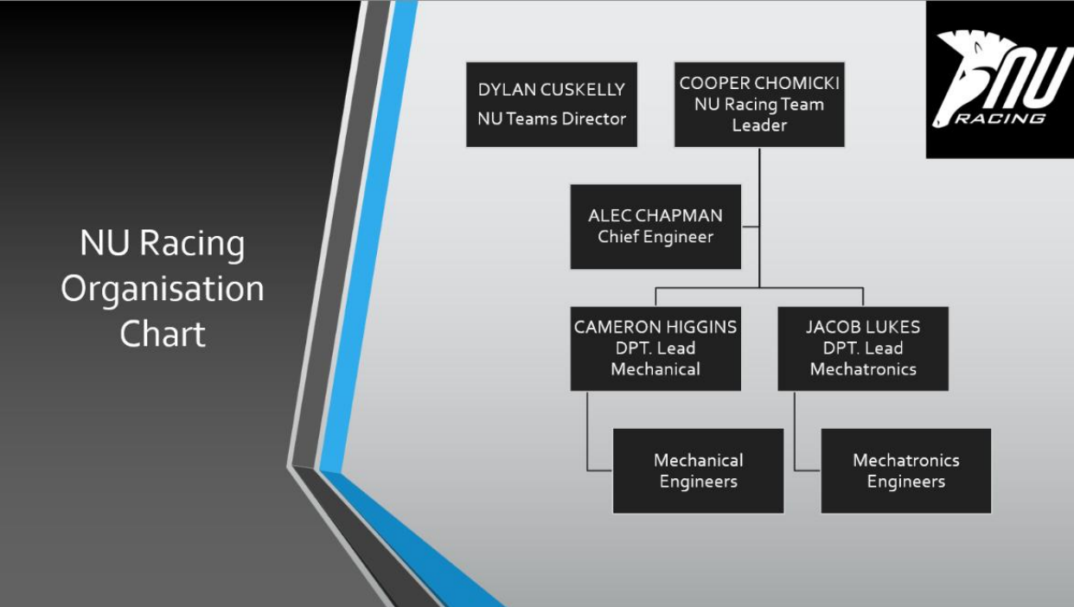
Figure 5. NU Racing Team Structure
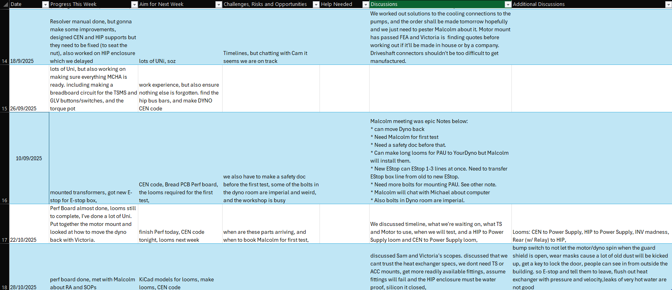
Figure 6. Dyno Progress Meeting Excel Snippet

Regulatory and Competition Constraints (FSAE-A Rules)
The engineering problem that FSAE-A gives to teams are as follows “Develop and build a rules compliant single seat race car that could be manufactured by a hypothetical engineering firm to sell at a profit to a weekend autocross racer.”
The overarching FSAE-A ruleset is the same as the FSAE International ruleset, it aims to give detailed constraints in some areas of design, such as safety and areas where there has been previous incorrect interpretation of rules. But overall attempts to allow for a wide range of solutions to the problem that it gives to teams. In addition to the International ruleset, there are also ‘FSAE-A Local Rules Addendums’ that are released periodically throughout the year. They give further clarification on certain rules from the International ruleset, to both help teams and outline the differences between the Australasia competition and the International one. At times these rulesets are painfully vague with their wording, and it is strongly encouraged that further NU Racing students contact the FSAE-A committee asking for rule clarifications, and store any replies received, as they serve as evidence against scrutineers for the chosen design during Technical Inspection.
The rules and addendums can be found on the SAE Australasia website, under ‘Formula SAE-A > Current-Year Competition > Documents & Templates’, screenshot provided in Figure 7. Instructions to Find FSAE-A Rules. It is strongly recommended to become familiar with this website early in the year, as it is messy and all over the place, and it is their main form of communication with teams, outside of direct email communication with the Team Leader.
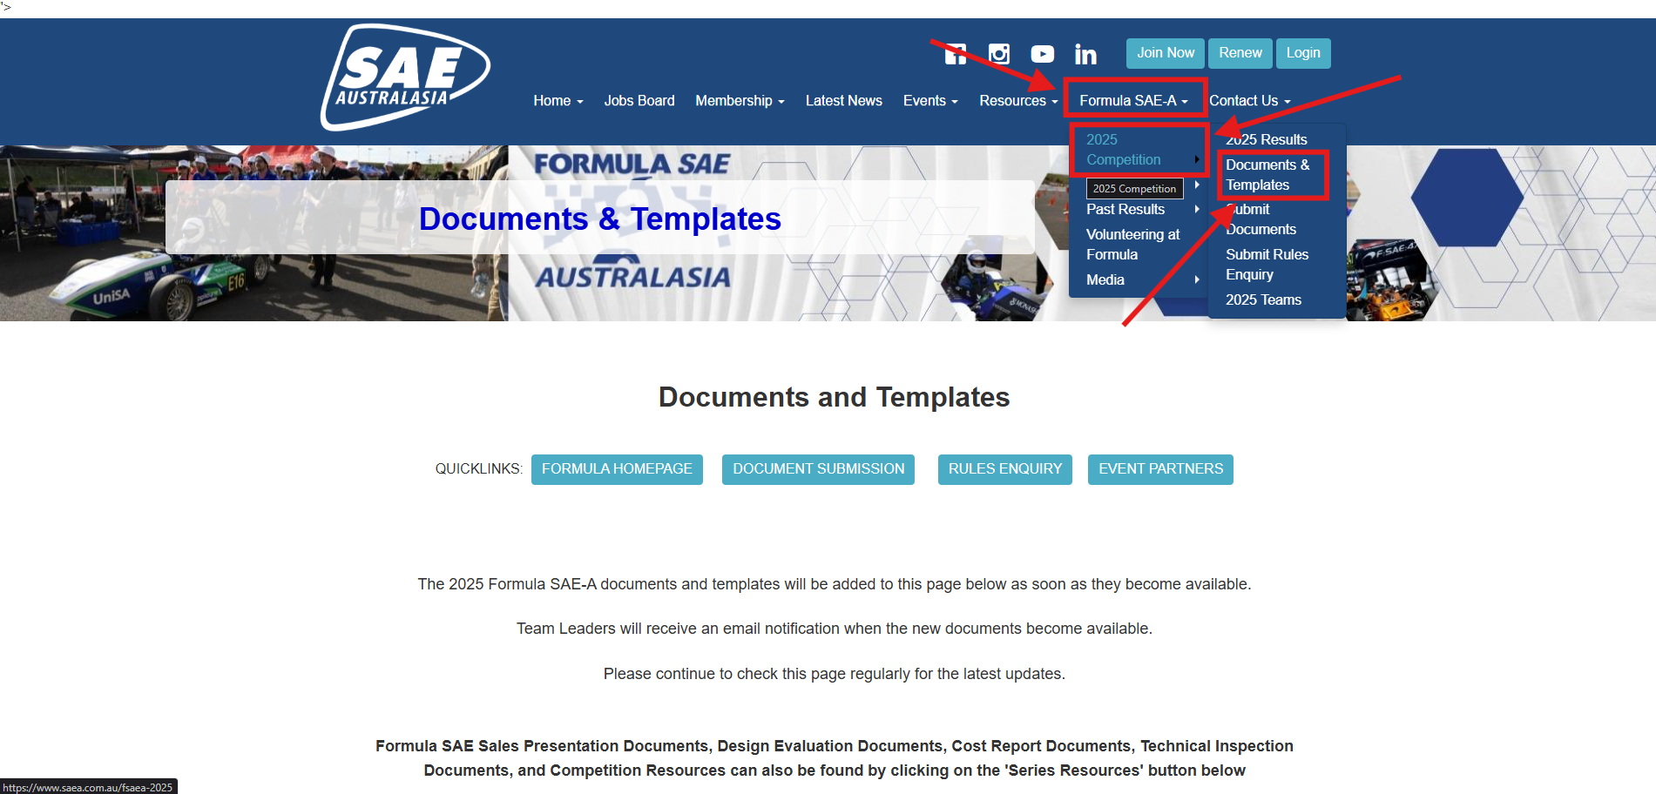
Figure 7. Instructions to Find FSAE-A Rules

Time, Resource, and Budget Constraints

Resource Constraints
At the beginning of the year, the leadership team was tasked with creating all the scopes of work for soon to be NU Racing members of the team. It was a juggling act of ensuring enough technical development was achieved for the year, while remaining within budget, ensuring all individuals had enough work to satisfy either FYP or Directed Reading course requirements and that members of the leadership team would not become overwhelmed with members to manage.
The author had assumed to receive a small number of students who studied the Mechatronics Engineering degree but was instead met with none and the team got many Mechanical students. To remedy this the leadership team picked those who were most interested in Mechatronic roles, as well as who would excel best in them, based off limited interaction with the individuals. This principle was followed because if a project is given to an individual with little interest in it, then they will not put much care or create much output during the year.

Budget Constraints
2025 saw a 23% decrease in budget from 2024, from $90,000 down to $69,000. This significantly impacted the scope of projects that the leadership team could produce. In 2024, the University of Newcastle had a system where NU Teams would be injected with a boost of money halfway through the year, but in 2025, this had been removed, causing further budget constraints and concerns from the leadership team.
The leadership team was tasked with creating a budget, summarising where money was to be spent during the year. It was encouraged to make three versions of this budget, each version promptly named ‘Splurge’, ‘Realistic’ and ‘Skeleton’. Within each budget giving an initial cost for the item, then with a confidence percentage on top, to show the NU Teams Director that the team understood where there would be unknowns and possible money sinks in a project, and where there were not. Splurge was made to see how much money the team could spend, if given no constraints, this ended up being around $166,000. Realistic, being what the team would ideally receive, of $70,000. Skeleton, what was the smallest amount the team could survive on and still make it to competition, this was found to be $53,000.
The leadership team decided to go with an extremely in-depth, itemised budget, providing as much detail as possible for each purchase, with the idea of if the number of unknowns were reduced, the teams initial budget of $70,000 would be more likely to be granted. Each budget was split into General, Mechanical and Mechatronic department purchases. The budget was successfully granted, and the leadership team was given praise for the work that went into the budgets creation.
The creation of the budget was closely linked to the number of projects that the Mechatronics team could undertake. Both the scoping document and budget were essentially created together, as one could not be finished without the other. It is encouraged that this workflow is followed in subsequent years, as it gives the team the most likely chance of receiving their desired budget, as it shows NU Teams Directors that the team is acutely aware of any money sinks that could be encountered during the year.

Timeline Constraints
The author also created a Gantt chart detailing project timelines up to June of 2025. This helped to see overlaps in project deliverables and potential clashes with integration of projects. While helpful, the author also recommends that future Mechatronic Department Leads should have a document detailing all remaining manufacture of a project. To help further detail what still needs to be done before a PCB, for example, can be put on to the car (e.g. enclosure manufactured).

Project Dependencies and External Interfaces
Being the Lead of the electrical systems on the car, this project was heavily reliant on both individuals of the Mechatronics and Mechanical team, to get the PCB, software and sensor integration done, but also how to effectively package all hardware components onto the car neatly. There was a large need for clean and consistent communication between the Mechatronic Department Lead Engineer and the Mechanical Department Lead Engineer. This was found to be most efficient form of communication between the departments as both individuals were most up to date across their department and were able to see potential clashes in integration early on. This was one of the areas of struggle during 2025, as there were times of inconsistent communication between the Department Leaders, which would lead to delays in new component integrations, and ultimately less track testing.
External interfaces for this project consisted of liaising with companies for component purchasing, as well as PCB manufacture. It is recommended that future Mechatronic Department Lead Engineers and other NU Racing students become comfortable with sending emails to companies asking for product updates, as well as potential sponsorships, to save the team money where possible.
When liaising with external companies, it is recommended to use a NU Teams/NU Racing email signature at the end of all emails. This helps with showing the company the team’s professionalism, helping yourself become familiar with using email signatures, as well as helping the company learning who you are. An example signature has been attached in the Appendix, Appendix A - Email Signature; the author encourages readers to use it and edit it to be their own.

Responsibilities and Management Approach

Technical Responsibilities of the Mechatronic Department Lead
Technical Responsibilities for the 2025 Mechatronic Department Lead were as follows:
- Maintain consistent and reliable validation of systems
- Overview data collection from onboard vehicle data logger
- System optimisation
- Compliance
- Innovation
- Provide technical knowledge to Mechatronics team
- Filter information to Chief Engineer and Team Leader
- Work with Mechanical Department Lead Engineer
- Aid in troubleshooting of Mechatronic systems
- Resource allocation
- Timeline management
- Budget overview
- Competition Technical Inspection and preparation
  - Electrical Safety Officer while at competition
- Help with Design event and preparation
- Help with Cost event and preparation
- Aid with preparing the car for each dynamic event at Competition

Safety, Compliance, and Quality Assurance Responsibilities

Safety-Critical System Oversight
Safety of team members was always the number one priority. The author aided with this in the following ways: ensuring all team members working on the car had correct PPE and informing and training members of the risks they were exposed to when working on electrical systems on the car. Ensuring all safety-critical systems were functioning correctly before the car was driven, as an example conducting the Accelerator Pedal Plausibility Sensor (APPS) check as well as testing the dash shutdown button and precharge/discharge circuit after work had halted on the car before a track day. Other ways include preventing unsafe and untested designs from reaching the car, enforcing validation and unit testing as much as possible to reduce the risk of a new component reaching the car and harming nearby systems or potentially the driver.

Competition Compliance
Compliance with FSAE-A regulations was upheld during the design process of new systems. During integration it was acknowledged that compliance could not always be achieved due to components having issues and safe work arounds being put in place to continue testing. An example would be that the DCDC on NU25 had to be manually started between power cycles due to a baud rate clash between systems. This was not compliant by FSAE-A rules but was fixed later by having all systems be on the same baud rate again.

Quality Assurance and Design Review Process
During the author’s previous experience in NU Racing years, it was acknowledged the importance of quality assurance. Previous year teams had created Design Decision Reviews (DDRs) to aid with the PCB creation process, minimising the chance of unreliable and dodgy designs making their way onto the car. The author upheld the DDR standard in 2025, incorporating previous lessons learnt into the DDR, such as a point for ensuring fuses to be added to traces that would power external systems to the PCB.
Other areas include holding a documentation standard for any test procedures or validation conducted throughout the year, maintaining consistent version control between PCB iterations, and training individuals on manufacturing looms. Crimping of pins (DT and Molex), where often the most common issue that caused wildly random issues to stem from.

Validation Gates and Readiness Criteria
Being an overarching team goal of 2025 to increase conducting and documenting validation, the author enforced within the Mechatronics department by requiring new circuits to be LTspice tested (simulated), proving their functionality, then adding another step to the design process of conducting sub and full integration test, reducing the number of unknowns at each step. Each stage was to be checked off by the author before the individual could proceed.
This extended strategy to the design process proved successful by the fact that the team completed 842 km of testing, with six new PCBs being introduced to the car throughout the year.

Budget Management and Resource Allocation

Budget Management
Throughout 2025, the leadership team struggled with a confusing layout for the budget. It had many revisions over the year and eventually ended up with something that we were happy with. The final approach was to have a summary positioned at the top of the document, of current money spent, the delta from the approved budget of $69,000, and other important aspects that the Team Leader and Chief Engineer requested to see briefly, example shown in Figure 8. Example of Budget Summary. Then within each section (General, Mechanical, Mechatronic), there were a ‘Spending Delta’ column for each item and their cost. This was used to see and easily track where overspending had occurred. This allowed decisions on subsequent purchases to be made easily. Example shown in Figure 9. Example of Budget Spending Delta.
The 2025 NU Racing Budget can be found in the NU Racing 2025 section of the NU Teams SharePoint.
Figure 8. Example of Budget Summary
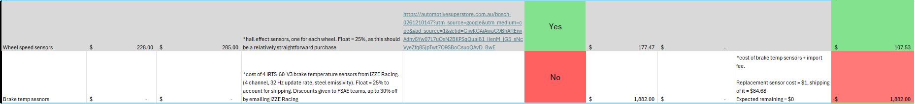
Figure 9. Example of Budget Spending Delta

Resource Allocation
The leadership team began this process by reviewing the year prior, and searching for bottlenecks in the system and areas that either needed or could do with improvement. Once this list was gathered, the author created multiple scoping documents for varying sizes of FYP and Directed Reading members that would join the Mechatronics team, from zero FYPs and four Directed Readings/Extracurricular up to five FYPs and two Directed Readings/Extracurricular. The multiple versions of any document should be avoided if possible and instead combined all into a single document. This helps with file management as well as ensuring information does not get lost in old documents.
The Mechatronics FYP team was comprised of two Mechanical students and one Aerospace Systems student. These individuals were chosen as they expressed interest in the respective roles. It turned out to be an extremely switched on and dedicated group of FYPs, which the author will be forever grateful for.
Aside from FYP students, the Mechatronics team relied heavily on Directed Reading and Extracurricular students during the entire year. During semester one the non-FYP Mechatronics team comprised of two Directed Reading students, Zak Lobko and Jayson Mills, and three Extracurricular students, Mia Cosentino, Oliver Dowzer and Hugh O’Brien. Though Oliver Dowzer and Hugh O’Brien’s projects were cut short due to lack of communication with the FSAE-A committee at the beginning of the year. In semester two, there was one Directed Reading student, Mia Cosentino, and two Extracurricular students, Fletcher Cogoi and Jayson Mills. These individuals were given specific projects, but there were many other individuals from the Mechanical and ENGG2200 cohorts who were given many small jobs but incredibly important jobs.

Communication and Coordination with Other Departments
Communication is by far the most important aspect of a leadership role. There were multiple times during 2025 were a breakdown in communication occurred between the leadership team, and it caused a noticeable negative impact on the rest of the team.
For the author, this occurred most with the Mechanical department lead. It is believed that it was a combination of neither of us attempted to dedicate time to ensuring communication was constant at the start of the year. Then when projects began to get busy, we had quickly forgotten and did not realise we were not communicating. The first consequence of this was during the integration of the new HIP PCB (V1.3). The enclosure had not been completed, and the author was about to cut and recrimp critical HV cables to interface with new connectors that had been chosen as a part of the new design. The Chief Engineer luckily had picked up on this, and halted work to ensure the upcoming track day was able to go ahead.
After this incident, the author and Mechanical department lead decided to dedicate an hour every Friday morning to go over where each department was up to in manufacture or integration. This helped significantly in highlighting areas of potential integration conflict.
Communication with the Team Leader and Chief Engineer was consistent through the weekly Leadership Meetings. Through the year though, the author realised that summarising all critical information about each project was difficult to do on the spot. To remedy this, the author ensured to take a quick five-minute break before a Leadership Meeting to gather thoughts and note any areas of concern, as well as areas of big wins.
In Leadership Meetings, it is recommended to take a cynical approach to conveying information about projects. This attempts to reduce the likelihood of forgetting to convey important information to the rest of the leaders during the meetings. After all the ‘fires’ had been talked about, then big wins can be talked about. The 2025 leadership team arrived at this approach towards the end of 2025 when there was little time to have leaders’ meetings, and issues were the main thing that had to be talked about. Otherwise, there was risk wasting time on topics that did not matter.

Engineering Decision-Making and Technical Oversight

Systems-Level Engineering Perspective
An FSAE EV race car is comprised of many systems and sub-systems. All that are interlinked in one way or another, like one massive spiderweb. Being able to see the links between the systems is a difficult task but must be done to be able to make informed decisions when it comes to making technical changes to the car.
All design decisions in 2025 for the Mechatronic systems had this philosophy in mind. For example, mounting of the Brake Over Travel Switch (BOTS) had to be positioned correctly in the Pedal Box to both ensure the brake pedal will press it if the brake master cylinders fail, but also not press it if they don’t fail, while also ensuring that the switch was rotated correctly so that the switch would be in the correct orientation when the car enters HV.
Vital aspects to consider when considering changes for systems are:
- Safety
- Compliance
- Reliability
- Inspect-ability (easy to show during Technical Inspection)
- Integration effort (how much needs to change to implement the design)

Design Review and Validation Strategy

Design Review
All new Mechatronic systems that went on NU25 in 2025 underwent a thorough design process. The process is outlined below.
- Design
- Simulate
- Manufacture
- Unit test
- Integration test
- Commission
- Validate
The stages of Design, Simulate, Manufacture, Unit Test, Integration test and Commission are all touched on in the Design Decision Review (DDR) document that is created for each PCB that is made. There was a template DDR version made in a Template File Structure folder in the NU25 GitHub Repository, which was copied and edited to each PCB made.
The individual making the PCB must not commence to the next stage of design until the stage they are up to in the DDR has been checked off by the Mechatronic Department Lead Engineer. This ensures that mistakes are not carried through the whole design process, then upon review at the end a small mistake is picked up on and costs many hours of reworking the design.
Each year this document is added to with lessons learnt within the year. The author recommends that the document and process is continued in future years. Due to both the number of times it has been tested and proven valuable, and due to it being a medium for easily carrying knowledge between the years.
After the DDRs creation in 2023, it is estimated to have been used to create over 32 PCBs, an estimated six in 2023, nine in 2024 (multiple iterations of each main PCB on NU24), and 17 in 2025 (also multiple iterations of each main PCB on NU25).

Validation Strategy
Being an overarching team goal for 2025, the team saw the first dedicated push to have every new system on NU25 validated, showing that a new design made a positive or negative impact to the systems around it and why.
Being the first year to push for it, there was not much infrastructure or previous knowledge on tested methods of validating Mechatronic system changes.
Most changes would show positive impact through data, being specific to the change. For example, once regenerative braking had been turned on in 2024, and math channels created in i2 Pro to calculate power regenerated through an endurance run, it was clear that regen had a positive impact and resulted in the Accumulator having far more capacity at the end of a run. More information can be found in Joshua Haywards FYP report [2], available on the NU Team’s SharePoint.
Smaller changes, such as changing a connector to a different type, would show improvements in ease-of-life, serviceability and service life of a system, but there were no hard numbers showing the change had a positive impact.
One of the failings of the author in 2025 was not creating a structure on how to validate Mechatronic systems particularly for smaller design changes.

Key Engineering Decisions and Trade-Off Analyses
The main design change for NU25 was adding in a Differential into the drivetrain. In 2024, the housing for the drivetrain, named Powerbox, had issues with bending under high torque loads from the EMRAX 228 Motor, more information can be found in Ty Doubikin’s 2025 FYP report [15], as well as Lachlan Fisher’s 2024 FYP report [16]. Both can be found in the NU Team’s SharePoint. Due to these two reasons, it was imperative that many kilometres of driving would have to occur to ensure the implementation of the Differential was safe and reliable.
As a result of, Mechatronic design decisions were centred around reliable operation of the car to maximise testing time and minimise the likelihood of electrical or control-related failures masking and potentially compounding drivetrain issues. The trade-off for this decision was the deferral of performance related improvements, in favour of stable, repeatable system behaviour throughout testing and competition.
Another area that the author was always concerned about was the Accumulator, since 2022, there have been many issues that were carried into competition, often costing the team many points lost in the competition due to the issues. Thus, it was decided to be the focus system to validate and ensure reliability. Only compliance level changes, this limited the scope of developmental experimentation but significantly reduced the technical and compliance risk.
In 2024, an issue with the CM200DZ inverter, it was sent off for repair, and a new one was bought, which also had integration issues. These issues accumulated to 3 months of wasted testing time between the end of July and late October. The broken inverter was received at the beginning of 2025, and was tested at a track day in May, where it showed no signs of being broken. This demonstrated a need for a conservative approach to validation and configuration for NU25’s tractive system.
The effectiveness of this method was validated at the 2025 competition as there was not a single issue caused by the Accumulator or Powerbox, a massive improvement from previous years and reflecting the substantial development and validation effort undertaken by Oscar Rudman, Ryan Bird and Ty Doubikin during the 2025 season.

Risk-Based Decision Making
Identifying engineering risk is critical. It appears in all aspects, from safety, compliance, reliability, and performance. In 2025 compliance, reliability and performance risks were not formally identified and documented, instead they were continually discussed and managed during Leaders Meetings. It is the authors recommendation to formalise this process earlier on in the year, so that if anything the leadership team are made aware of areas to be cautious.
The only formal structure of risk awareness was within the budgeting stage of the year, where the leadership team was tasked with applying ‘Factor of Importance’, an estimated percentage of how unknown the cost of an item would be, ultimately referring to the risk involved in the design of the system.
An example tolerance structure of how risks in safety, compliance, reliability, and performance could be hierarchised with the NU Racing mindset is shown below
- Safety risks: zero tolerance
- Compliance risks: very low tolerance
- Reliability risks: zero tolerance
- Performance risks: moderated/managed tolerance
Through discussions of risk in leadership meetings, the leadership team were able to identify designs that required more in-depth unit testing and validation before the design was deemed reliable. This was most prominent in the Powertrain project, though another area where this philosophy was used was in the Expansion Board project, where the author saw Oliver Bunny’s scope as major risk since the team had not undertaken a PCB that integrated the number of sensors that was desired. As a result of this, the author ensured to dedicate large amounts of time to design reviews of the PCB and ensure that there was in-depth testing procedures created to prove the PCBs functionality. This decision was validated with the success of the PCB, having all sensors tested during 2025, allowing significant Vehicle Dynamic research, powertrain cooling research, informed and efficient driver training, and informed brake pad selection to be conducted.
The discussions within leadership meetings significantly reduced the amount of risks the team faced, though where residual risk remained, acceptance was contingent on mitigation strategies, and ultimately an assessment that further reduction was not feasible within the available timeframe. Residual risk was most pronounced in the inverter issue that the team faced after Acceleration event testing had been conducted with the Differential Powerbox. After researching the fault, the team acknowledged that the solution could not be implemented in the available time left before competition. Instead, a temporary fix of limiting the torque during Acceleration runs was implemented. More information can be found in Samuel Connett’s FYP report [7].

Mechatronic System Development and Integration

Overview of Mechatronic Systems on the Competition Vehicle
An overview of the Mechatronic systems of NU25 are depicted in NU25 Mechatronic System Architecture. A more detailed overview of the electrical connections and system topology can be found in Appendix C - NU25 Electrical System Overview

Design Evolution and Change Management
NU Racing follows a ‘build first, design second’ philosophy. In 2024, most designs had been decided for NU25. In 2025, the Mechatronic systems were required to change as little as possible, as discussed in the Key Engineering Decisions and Trade-Off Analyses section of this report, only minor revolutions to designs were allowed. This resulted in the author creating a detailed list of changes to each node, a process that has its cons and are discussed in the Onboarding, Training, and Mentorship section of this report.
Designs were evaluated with the help of consultation with the Chief Engineer, Malcolm Sidney and Dylan Cuskelly. Along with Decision Matrices, that allowed for un-biased decisions to be made in a quantitative way.
During the year, the author found it difficult to keep track of changes to the race car (NU24 and NU25) between each track day. Thus a ‘Changes to NUxx’ list was written up on a whiteboard in the TA workshop. This was found to be a quick and efficient way of capsulating changes to the car. The author thought it was beneficial to ensure that the method of documenting the changes were quick, because of the reduced time both the author and Mechanical department lead had to document the changes, a whiteboard in the workshop seemed most fitting. After the changes were finalised for the track day, the Chief Engineer would then formally document the changes in the ‘NU Racing Track Day Testing Log’. A process that the leadership team found to be efficient. An example whiteboard summary is shown in Figure 10. Whiteboard Change Management Solution.
This whiteboard summary also helped to fault find during track days. Since it was usually an integration issue that was causing a fault, being able to quickly see what the changes were for the track day allowed the Mechatronics team to efficiently find and fix issues. Resulting in more efficient use of track days and increasing driving time.
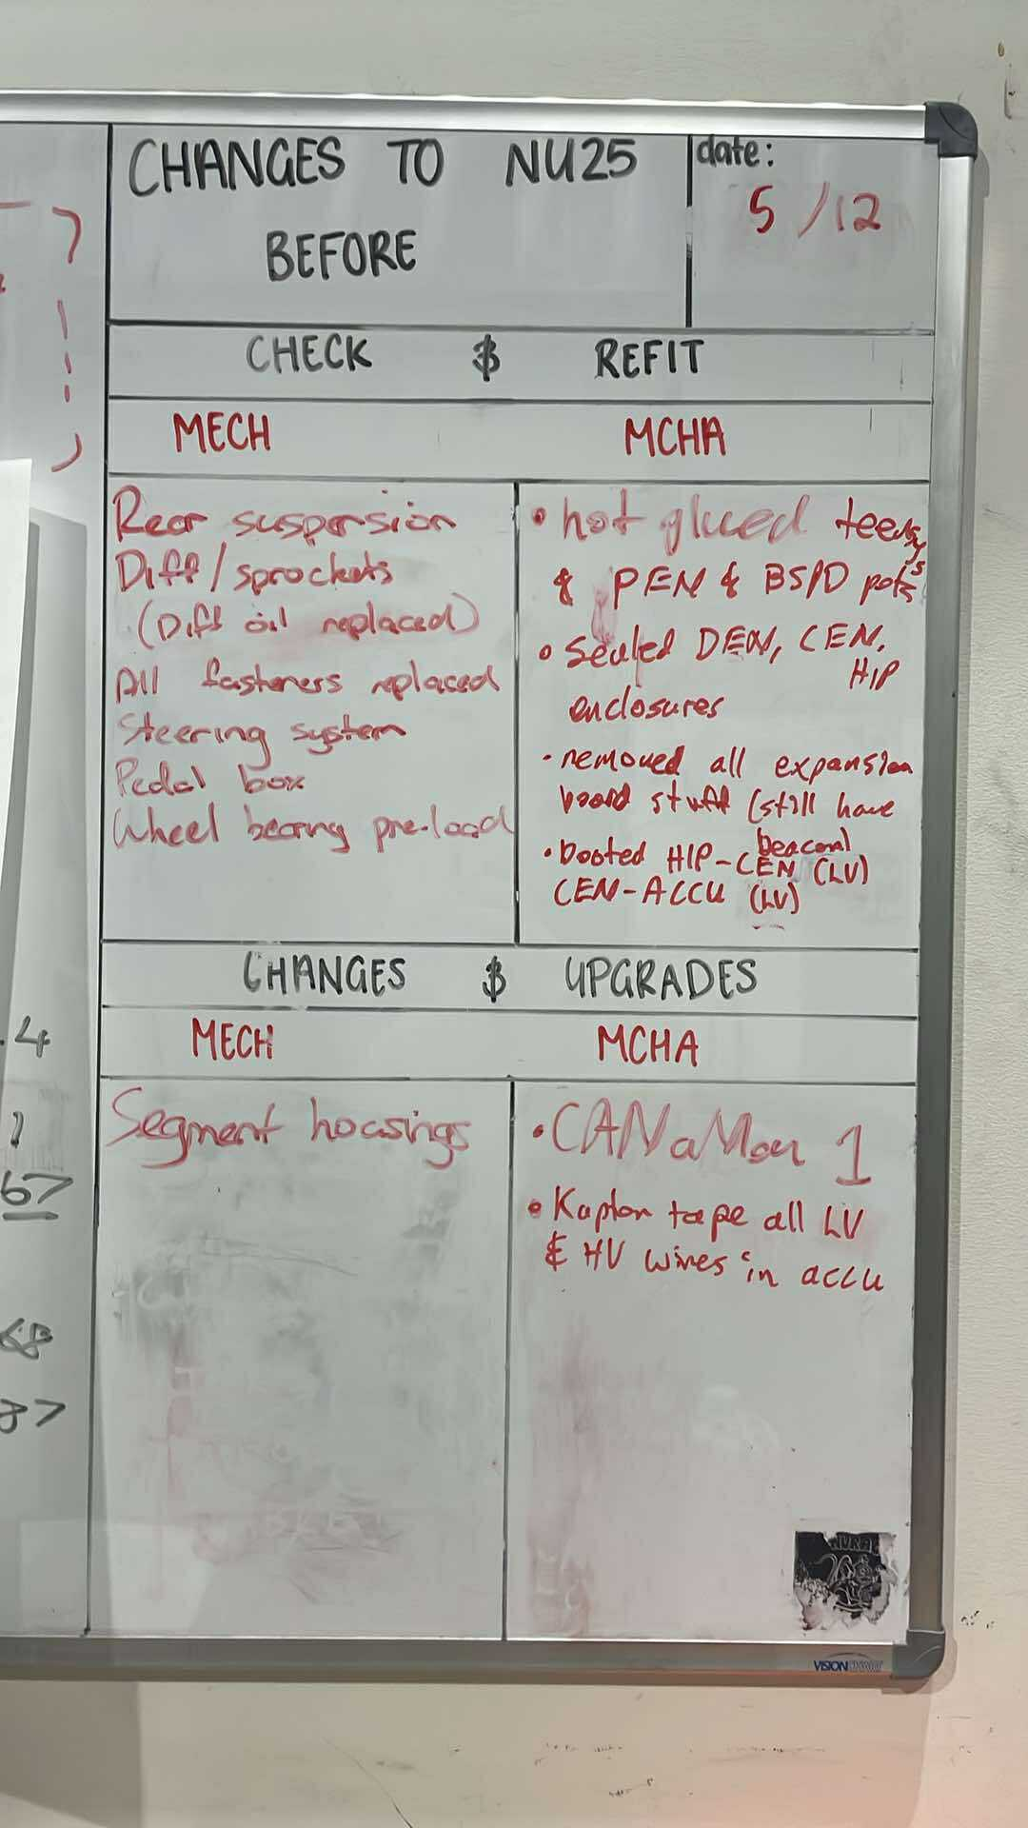
Figure 10. Whiteboard Change Management Solution
Other forms of change management included the creation of a document called ‘2025 MCHA System Design Changes’, that outlined all the changes to PCBs made in 2025. Available on the NU Team’s SharePoint as well as in Appendix E – 2025 MCHA Systems Design Changes. Design Decision Reviews (DDRs) were also used as change management, at the beginning of the DDR, there is a section that gets the individual to detail the changes to the new PCB version compared to the last version. DDRs are further discussed in the Quality Assurance and Design Review Process and Design Review and sections of this report.

Integration with Mechanical and Vehicle-Level Systems
- PCB and enclosure issues (CEN and HIP mounting)
- Sensors on wheel assembly (uprights)
- TS stack (DCDC, inverter, lv battery)

Issues Encountered During System Integration
- Implement as many steps as possible to integration to make sure that everything that can be tested is tested before it is all put together
- Do a dedicated test day of new mcha systems on previous years competition car. Makes so that (ideally) all changes to mcha system is tested before new competition car is running

Testing, Validation and Compliance
- ESF
- NU25 Testing
- NU24 Auto X issue (BMS fault, cell 7 and 8 low and high voltage fault. P0A80??)

Validation Strategy and Test Philosophy
Validation is the process of ensuring that a product, service, or system meets the operational needs and intended use of the end user [17]. It is a critical step in the engineering process, as it is the direct way to know if a change to a design has made a positive impact or not. It ensures safety and aids to decrease the risk of a new design.
With improvements in 2025 with validation in NU Racing, the ideal strategy employed consists of testing a design in a controlled environment, one where unknown and uncontrollable variables are kept to a minimum, or if possible reduced to zero.
New designs should only be allowed on the competition platform once controlled validation has taken place, and unit tests have been successfully passed. This method reduces the number of unknowns and late-stage failures of a new design as much as possible. Though note should be taken that one cannot remove all possibility of an element being missed.
In 2024, it was demonstrated that insufficient or mislead diagnostic clarity and methods could lead to misidentification of hardware faults, further reinforcing the need for a staged, multi-step validation and unit testing process.

Simulation and Unit Testing
The author insured to push for simulated circuits before PCBs could be ordered in 2025. This proved to help with individuals understanding of the circuits on their PCBs, as well as easily highlight circuit designs that would not work.
The chosen software in 2025 was LTspice, due to it being taught in University courses, as well as its wide range of components and its large online community. Other simulators included Falstad, an online quick to use real-time simulator. Though not as in-depth and good as LTspice, it was used to quickly sketch a circuit and test its functionality with a visualisation of current flow.
Simulations of circuits are recommended to be conducted in future years.

Unit tests were an extremely valuable tool throughout 2025 in the creation of PCBs; it helped to find issues once a PCB had been manufactured but not yet put on the car. An in-depth unit test plan and check list can save many hours troubleshooting on the car. A detailed example unit test checklist written by Mia Cosentino is provided in Figure 11. HIP V1.4 Unit Test Checklist.
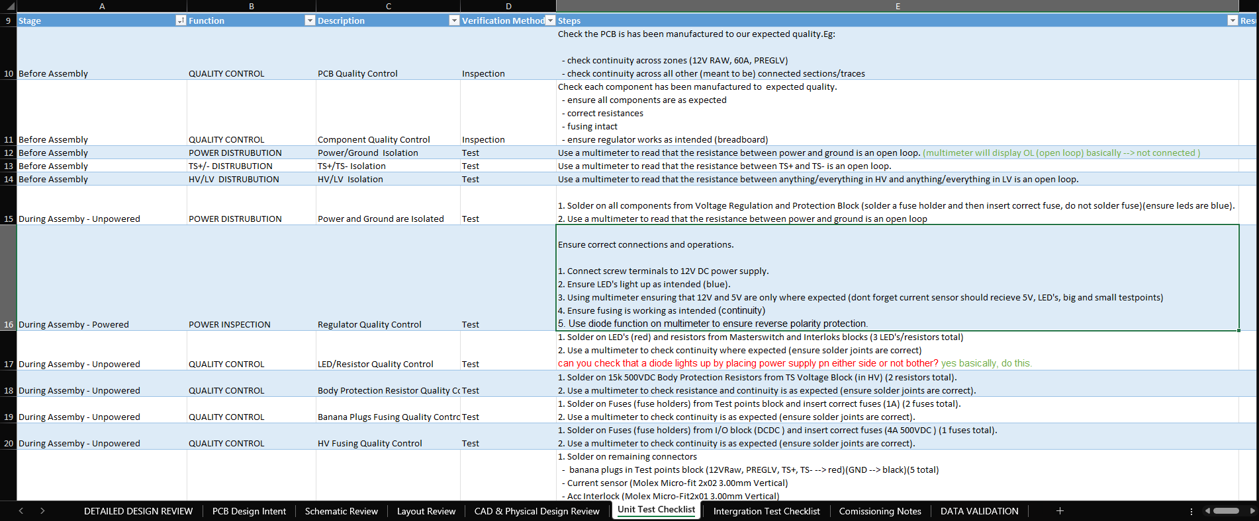
Figure 11. HIP V1.4 Unit Test Checklist
Another area where unit tests for Mechatronic systems occur was in loom creation, by continuity checking looms to ensure pin outs were correct. In 2025, there was no way of unit testing parts of the Tractive System, such as the motor. Once the Dynamometer is functional, it will fill this gap.
Further discussion on the positives of simulation and unit testing can be found in sections Validation, Validation Gates and Readiness Criteria and Design Review of this report.

Integrated Vehicle Testing
During integration testing in 2025, many issues were found and fixed, below is a summary of some of the issues encountered. Further information about each issue can be found in NU Racing’s Lessons Learnt document, available on the NU Team’s SharePoint.
- Removing motor controller interlock connectors inside hip before comp (from track day testing they would rattle and disconnect)
- Inverter overcurrent faults (more information found in Samuel Connett’s FYP report)
- Inverter DC overvoltage faults (more information found in Samuel Connett’s FYP report)
- CEN code upload issues
- Updating the cars DBC without updating code on nodes where changed signal IDs came from
- Beacon issues
- DCDC baud rates
- AIL popping capacitors during power cycle
- BSPD tuning
- BOTS issues with shutdown circuit not turning on interpose relay (and the car)

Orion 2 BMS Data Viewer Software
Battery Management System (BMS) faults were frequent at track days. When the BMS does fault, it stores a snapshot of parameters within the BMS at the time of the fault. It creates a CSV file that can be viewed and saved to disk from the Orion 2 BMS software. With significant help from the AI Claude, the author made a Python script that takes the CSV files as input, and outputs graphs of cell resistances, as well as open and instantaneous cell voltages.
The author enforced the need to save the CSV files to disk after a fault had occurred, as in previous years the fault would simply be cleared after viewing the CSV, and the CSV would be lost. The author found this useful to quickly see what cells were causing issues and that may need replacing. This script can be found in the BMS folder in the Racing-NU25 Github Repository.

Technical Inspection Preparation and Outcomes
Technical Inspection at the FSAE-A competition is extremely important. If one of the eight Inspections are not passed then the car is not able to compete in any of the dynamic events at the competition, were 67.5% of the available competition points lie. If done efficiently, they significantly reduce the stress felt by team members during the competition, which is incredibly valuable.
Though a struggle, the team performed extremely well in Technical Inspection at the 2025 competition, the team Mechatronic team passed EV Static Technical Inspection first try, Accumulator Technical Inspection second try, and EV Functional Technical Inspection first try.
The hard work was rewarded, competition recognised this by awarding NU Racing with the Technical Inspection specialty award, shown in Figure 12. 2025 Technical Inspection Award. This award could not have been achieved without the endless hours of dedication from the Mechatronic and Mechanical team members who were present and helped with Technical Inspection.
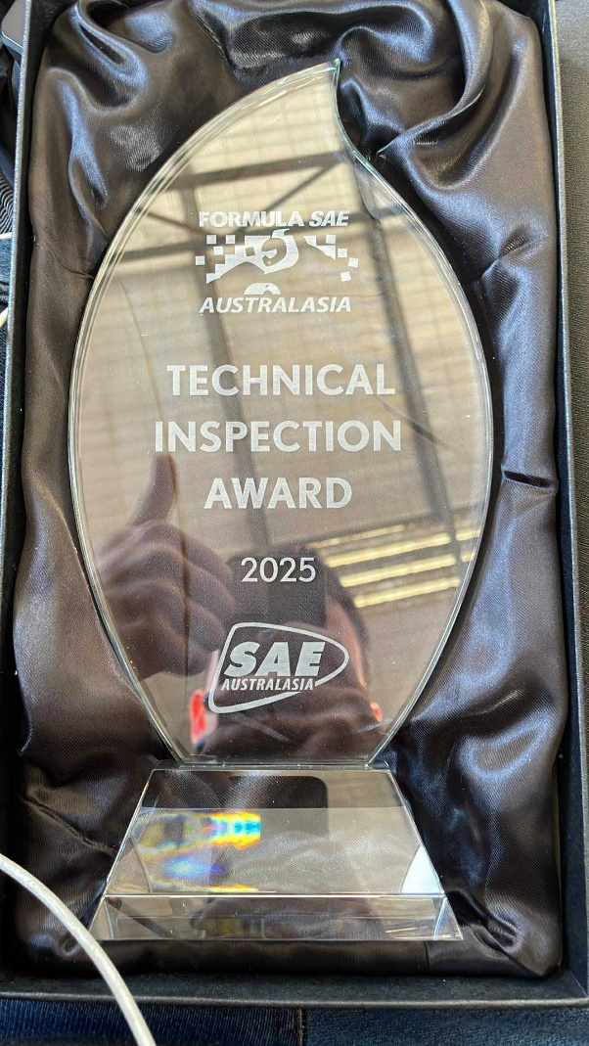
Figure 12. 2025 Technical Inspection Award

Inspection Strategy and Preparation

Practice Technical Inspections
Mock Technical Inspections are extremely important to conduct throughout the year. They help team members involved in Technical Inspection to learn and practice for the Technical Inspections at competition. In 2025 these began in late July, with the Technical Inspection sheet for the 2025 competition released October 24th, weekly Technical Inspections occurred from late November. It is recommended that these occur more frequently throughout the year, as it was a push and down to the wire to get the car compliant in 2025. It is important to get in as many Alumni for this process as possible, as it is an easy way to get multiple informed perspectives on the team’s preparedness, as well as the compliance of each system.

2024 & 2025 Philosophy and strategy to Technical Inspection
In 2024, the Mechatronic Department Lead Engineer, Alec Chapman, created a ‘MCHA Bible’ for Technical Inspections. Which were the Technical Inspection printed out with brief descriptions of how to answer each point. The author saw how effective these Bibles were and decided to continue their use in 2025. They are available in the Technical Inspection section of the SharePoint, as well as in Appendix D - 2025 Technical Inspection MCHA Bible.
Also carried from 2024 was to have a dedicated document handler present at each Technical Inspection. The role of this person is purely to handout and organise all documents that are required for the given Technical Inspection. This helped with the fast-paced environment that Technical Inspection becomes.
Technical Inspection is ultimately a battle of interpretations of the competition rules and technical inspection points. It is vital to remain level-headed and calm during competition Technical Inspection. It is likely they will pick up on points or interpret a section differently to how you have. You must be prepared to argue your interpretation, as well as provide evidence and reason with the Scrutineer. Do not fold immediately when they pick up something, since at times they have not fully read the Technical Inspection point, or have read it wrong.
It is important to note that not all the Scrutineers have experience in the topic they are inspecting, be prepared to have to explain or let them figure out the Technical Inspection points on the spot and even guide them to your understanding of the point, to help pass it quicker.

Technical Inspection at Competition
Then there are the Scrutineers who have been doing it for years and enjoy pulling teams up on small insignificant points and interpretations. They will stick to their guns and will not change their mind without a calm counterpoint from yourself. If they really are extremely not happy with a design, the Technical Inspection Captain will be called upon to give a final decision. In 2024 and 2025, this person was easy going and waived most concerns.
An aspect that can be used to your advantage is the chaos of the situation, in 2025 there were three Scrutineers in EV Static, two in four in Accumulator Technical Inspection, and one in EV Functional. It is very situational, but the Scrutineer may skip points or brush over stuff in the essence of time. If this occurs, again very situational, but it is possible to leave it and hope they don’t pull you up again on a potentially non-compliant point.
Each Technical Inspection is given one hour to be completed; this is done since the competition has many teams to get through in the two days given to run static events. Due to this, the team has historically and did the same in 2025, constantly snooped and checked if Technical Inspection bays were free to see if the team could jump the queue. This has been valuable as often teams are not very organised, and it gives extra time if issues occur in the given Technical Inspection.

Advice to Future NU Racing Students Undertaking Technical Inspection
- Do as many mock Technical Inspections as reasonably possible. They will start out with extremely poor performance, but over time the team will learn and the car more compliant, it is only repeated attempts at Technical Inspection that create an efficient and compliant car.
- Use and replicate the ‘MCHA Bible’.
- Dedicate specific people to each Technical Inspection, with a dedicated document handler.
- Best advice is to prepare as best you can, gather as many documents as possible to prove that the given design is compliant.
- Be prepared to have to argue your interpretations or even explain the Technical Inspection points to the Scrutineers because they read it wrong or not fully.
- Use the chaos of the situation to your advantage.
- Continually check to see if other Universities are dropping the ball and not showing up to their Technical Inspections and jump the queue if the chance arises.
- Be wary of both in-experienced and experienced Scrutineers either not reading points correctly or having an out-dated understanding of how a point works. As well as experienced Scrutineers looking to bite you on the smallest of things. Like grounding of hose clamps….
- Be confident, be prepared and argue your interpretation of rules.

Accumulator Technical Inspection
In 2025, the Accumulator Technical Inspection was split into three sections, safety tools check, charger check, and the actual Accumulator check. Due to the one-hour timeslot allocation, the author split the team into two groups, charger and Accumulator. The Accumulator team would conduct both the tools check and the actual Accumulator check itself. There was a dedicated document handler for the charger and Accumulator sections.
Once the Accumulator Technical Inspection is passed, the Scrutineers hand the team a thermal strip, to place on the most negative terminal of the Accumulator. In 2025, it was placed in the location shown in Figure 13. Thermal strip viewing hatch. This was inspected later in Parc fermé, to show that the Accumulator did not exceed temperature restrictions defined in the Accumulator Technical Inspection sheet. Further information on Parc fermé can be found in the Parc fermé section of this report.
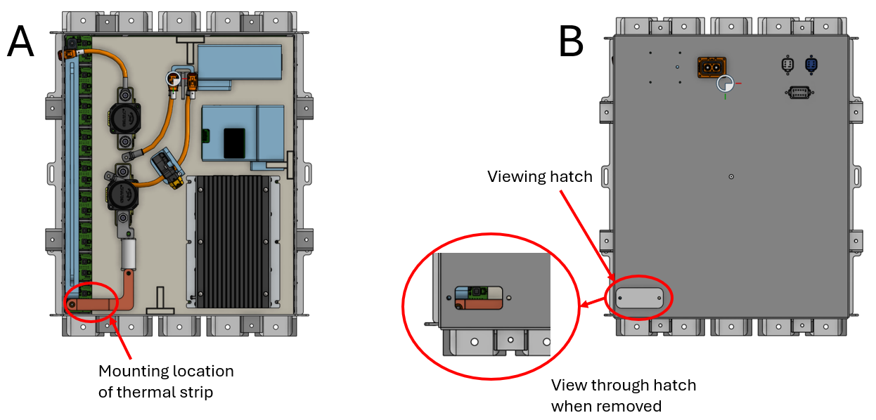
Figure 13. Thermal strip viewing hatch
At competition the team was able to do the charger and tools sections early. The tools section passed first try, but the charger section did not.
The charger section consisted of both an Accumulator trolley inspection as well as the charger inspection. The Scrutineers picked up a very small wire located at the back of the charger that was un-terminated. The author is still shocked that they managed to see the tiny wire in the depths of the charger, but they were right. They also picked up on that the handle of the charger trolley was not correctly grounded when the charger was earthed to the trolley. After checking with the Technical Inspection Captain, the charger was brought back to the pits and disassembled to remove the un-terminated wire. To resolve the trolley grounding issue, a earth wire was simply run from the trolley ground connection point to the trolley handle. Once the changes were complete, the team brought the charger and trolley back to the Technical Inspection area and both sections passed.
The Accumulator Technical Inspection failed on its first attempt. The Scrutineers failed the team on exposed copper connection on the Radlok pin that the quick disconnect to the lid attached to, it could be touched with a 6 mm diameter, 100 mm length probe, which is not a point in the Accumulator section of the Accumulator Technical Inspection, but it was a valid concern. The other point where they failed the team on was the nuts holding the AIL to the lid of the container, they were nylon nuts on nylon bolts, which the author initially decided to go with so that there was not a metal bolt extruding from the inside of the Accumulator, but forgot that it had to be positively locked.
These two fails meant that the first Technical Inspection had to be stopped, and the Accumulator brought to a clean room to disassemble to make the make the changes. They luckily were quick fixes. Both issues are shown in part A and fixes shown in part B in Figure 14. Accumulator Technical Inspection Fail Point 1 and Figure 15. Accumulator Technical Inspection Fail Point 2.
Once they were fixed, the team requested that a Scrutineer came over to the clean room to check the changes done. They were happy to do this, and it saved the team having to reseal the Accumulator and take it back to the Technical Inspection bay. The Scrutineer was happy with the work conducted, though he noted that we were using rubber like tape as insulation in the case of Figure 14. Accumulator Technical Inspection Fail Point 1, which would violate AI.5.24, but was happy to pass it at the time. Care should be taken in future years around this point, as well as be aware that they could check for things that are not explicitly stated in the given Technical Inspection but instead show up in other parts of Technical Inspection. For example, the touch protection point they caught us on is a point in the charger section of Accumulator Technical Inspection (AI.4.18) and a section of EV Static (SI.5.2).
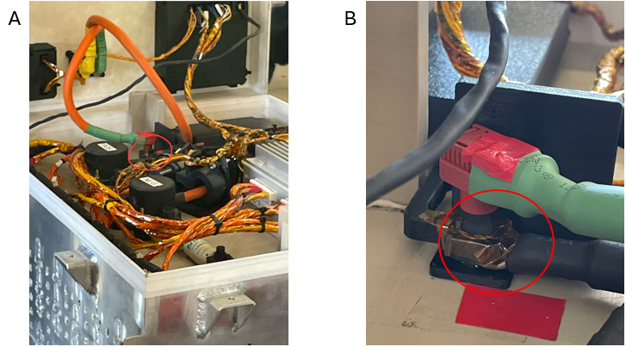
Figure 14. Accumulator Technical Inspection Fail Point 1
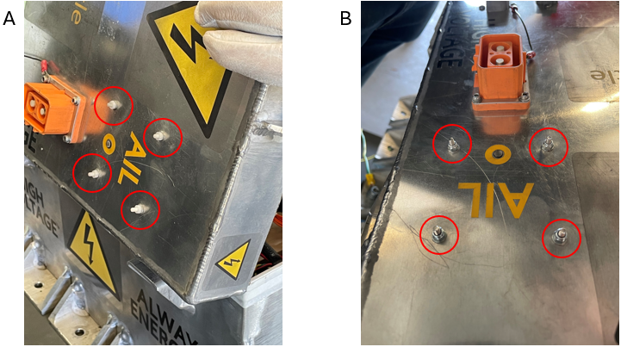
Figure 15. Accumulator Technical Inspection Fail Point 2

EV Static, EV Functional and Rain Test

EV Static
EV static passed first try. Though there were points that the Scrutineers picked up on, and after some debate and small argument, they were happy to pass. These points include:
- SI.8.2, the phase cables that entered the motor were not sufficiently secured. The point made was that the crimp was being strained, which is valid. It is recommended that this is fixed for 2026, possibly with the use of cable glands. Depicted in Figure 16. Visualisation of where phase cable securing is needed.
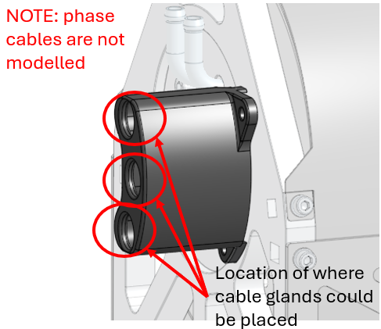
Figure 16. Visualisation of where phase cable securing is needed

- Not a point in EV Static, but the external bolts that hold the MSD in place on the HIP must be positively locked. They briefly mentioned it at the start of EV Static, but forgot to recheck it, because it is not a point. One solution that should be implemented in 2026 would be to lock-wire the two bolts together. Illustrated in Figure 17. Location of MSD bolts that should be positively locked.
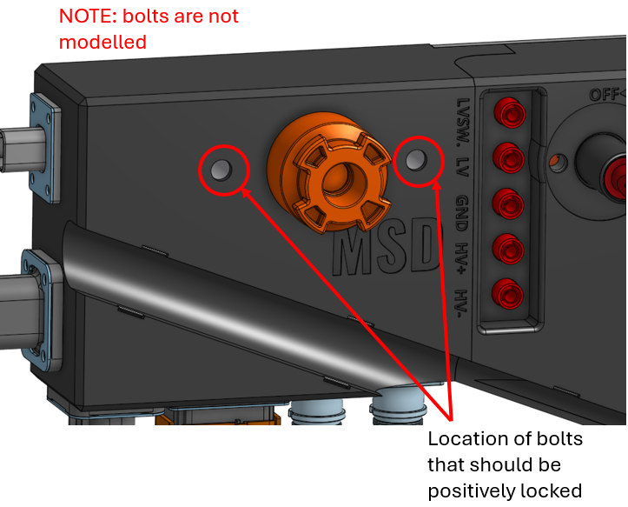
Figure 17. Location of MSD bolts that should be positively locked
- SI.5.2, when the MSD is removed, it could be argued that the contacts inside the MSD enclosure that are exposed can be touched with fingers. But the 6 mm diameter probe cannot touch the contacts. It is recommended to 3D print a cover for this in future years, just to cover your ass in case they get annoyed by it. Figure 17. Location of MSD bolts that should be positively locked, shows item of discussion, except that the MSD is in place in the figure.

- SI.18.16, they were not happy that the seat belt harnesses were not grounded. It is specified that items only need grounding if they are within 100 mm of HV components. This Scrutineer did not seem to care about this and pushed very hard for this point. The author and Jayson Mills were sitting there sanding the heck out of the chassis to make the connection for the seatbelt harness holders (shown in Figure 19. Seatbelt harness holder locations), but they were not making a good connection. The Scrutineer ended up folding and waived it as not necessary. Though the point of components not needing to pass the 0.3 Ohm grounding requirement (shown in Figure 18. Showing 100 mm proximity grounding requirement in EV Static), the Scrutineer continued to check the grounding of items such as the steering and pedal box assemblies. From the perspective of the Technical Inspection point, the author was very confused why they were checking these components. But from the perspective of safety, it is very understandable that they would check this, as if the chassis was to become live with HV in the event of an accident, bad connections to the steering and pedal box assemblies could become hot if current was pulled through them, but then again there is very little chance of that ever happening. This is an example of the Scrutineers checking random things that are not on the Technical Inspection sheet, either because it used to be a point in previous years, they get a kick out of it.
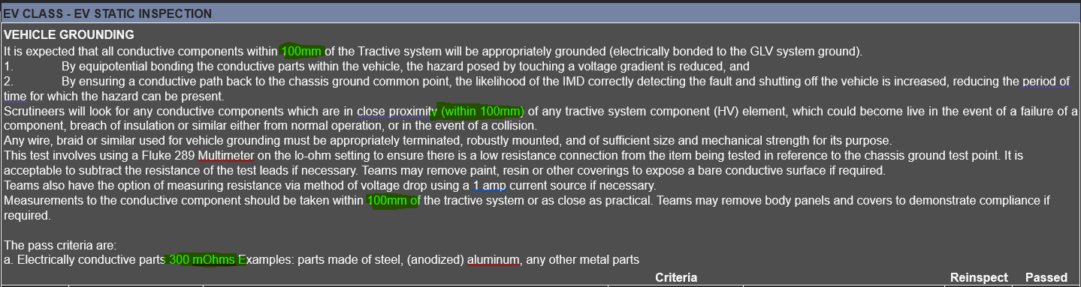
Figure 18. Showing 100 mm proximity grounding requirement in EV Static
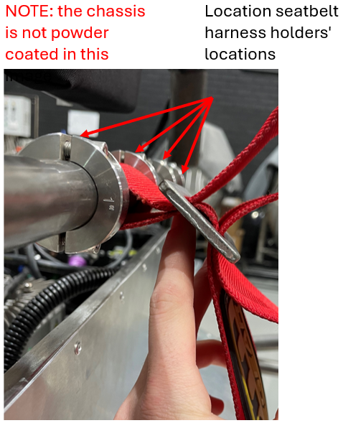
Figure 19. Seatbelt harness holder locations

EV Functional
The team passed EV Functional first try. A massive attribute to all members from the Mechatronics team that were involved with both preparing for this event and who took part in the event.
During preparation for this Inspection, every mock Technical Inspection for EV Functional had something go wrong. Often it was the Brake Over Travel Switch (BOTS) mechanically failing during the shutdown circuit section. Shown in part A of Figure 20. A) shows location of BOTS in Pedal Box. B) describes reason for continual breaks, the switch was failing due to the frequent servicing of the brake lines in the pedal box. When serviced, brake fluid would get everywhere, and overtime caused the plastic of the switch to deteriorate. This combined with a poor mounting solution that created a moment on the thread of the switch, caused it to fail when operated. This was fixed by constant replacing of the switch, especially close to competition once brake line servicing stopped, as well as a proper mounting solution of supporting the switch housing by the base. Described in part B of Figure 20. A) shows location of BOTS in Pedal Box. B) describes reason for continual breaks
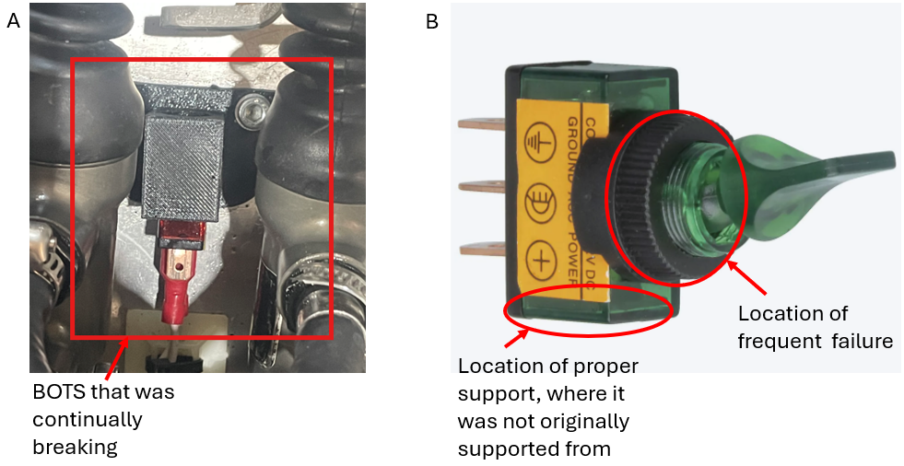
Figure 20. A) shows location of BOTS in Pedal Box. B) describes reason for continual breaks
There were also two instances of the fuse on the output of the interpose circuit on the Central Electric Node (CEN) would blow due to the frequency of switching on and off the Tractive System. This was occurring due to an incorrectly specified fuse, it was set to 1 A, when it should be a minimum of 2 A due to the transient current draw of the MegaVac Isolation Relays used in the Accumulator. This fault was occurring very close to competition, so the author decided to put a 10 A fuse in the holder just in case. Fuse location shown in Figure 21. CEN fuse that was blowing during EV Functional Mock Technical Inspections.
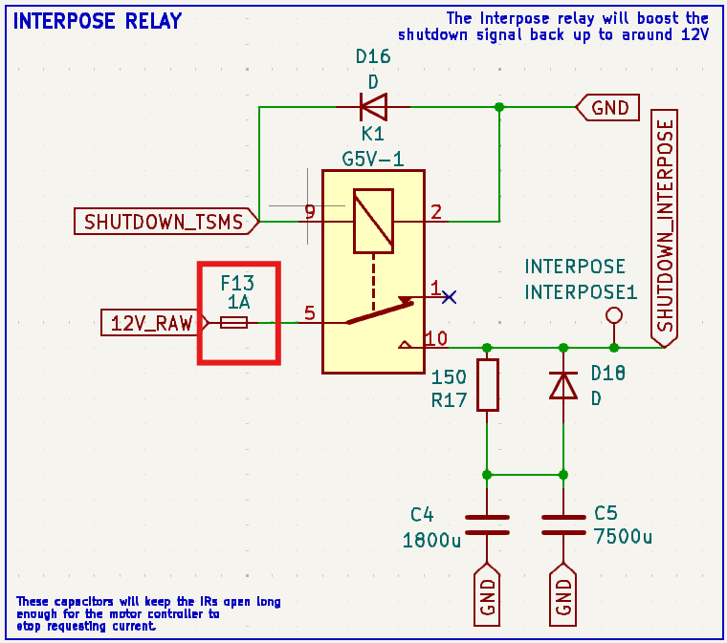
Figure 21. CEN fuse that was blowing during EV Functional Mock Technical Inspections
During the last EV Functional mock Technical Inspection, an Alumni found a weak point in the compliance of the teams Insulation Monitoring Device (IMD) test resistor box. The Technical Inspection point in question was FT.5.2, shown in Figure 22. FT.5.2 Explanation.
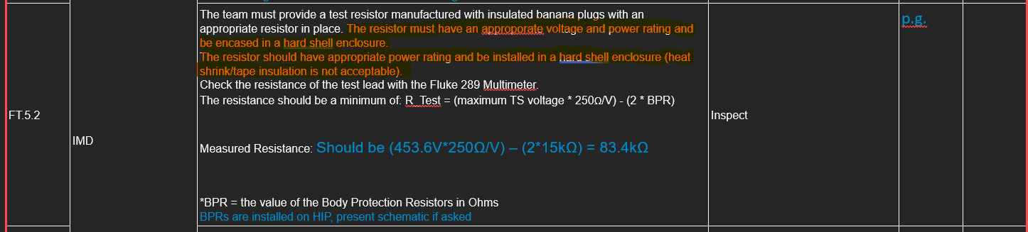
Figure 22. FT.5.2 Explanation

Which is already a confusing point but can be easily interpreted as the test resistor must be rated for the correct power and voltage. Which the author had not prepared material to prove that it was. Because of the author explained that there was a single resistor with a power rating of 1 W, rated to 500 V inside the enclosure, the Alumni asked if that was enough and said to prove it, the author did an on the spot calculation and it showed that it was not rated for the expected power of 1.8 W. Due to the author’s lack of confidence in answering the question, the Alumni had asked for the enclosure to be opened, which showed that there was two resistors in series, meaning that the dissipated power between the two was 0.9 W, very close to the 1 W rating the author had told the Alumni.
It also showed additional screw terminals in the box that was not rated for 500 V, as well as a dodgy solution. The box is shown in Figure 23. Non-compliant IMD Resistor Box.
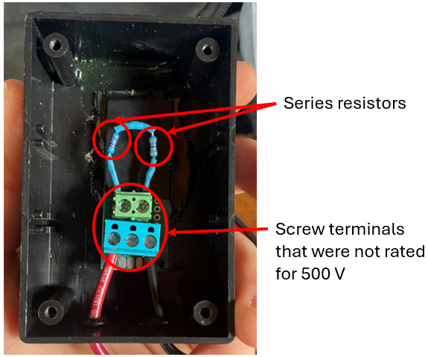
Figure 23. Non-compliant IMD Resistor Box
After the mock Technical Inspection, the author quickly made this a priority to fix and gather evidence showing that it was compliant.
To start, the author said that the resistor was instead rated for 2 W, this option is not recommended, but with the author had three days before the competition EV Functional Technical Inspection. Next, the author asked Oliver Dowzer to print an enclosure for the new solution. Malcolm Sidney advised that a solution to removing the screw terminals would be to solder wires directly to the resistor legs, then retain the wires through the enclosure with cable glands. The compliant solution is shown in Figure 24. Compliant IMD Test Resistor Box. The author then wrote up hand calculations showing that the 2 W power rating were a significant safety margin for the actual power that the resistors would dissipate. The hand calculations are shown in Figure 25. Proof of IMD Test Resistor Power Requirement Compliance.
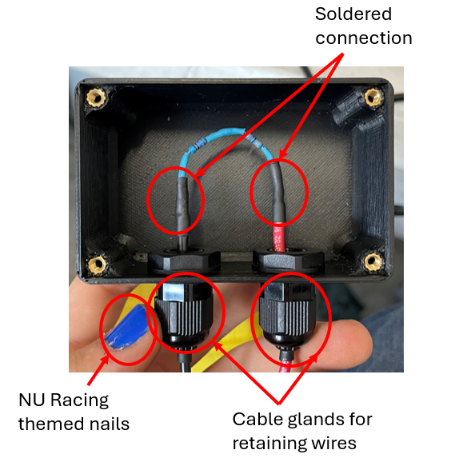
Figure 24. Compliant IMD Test Resistor Box
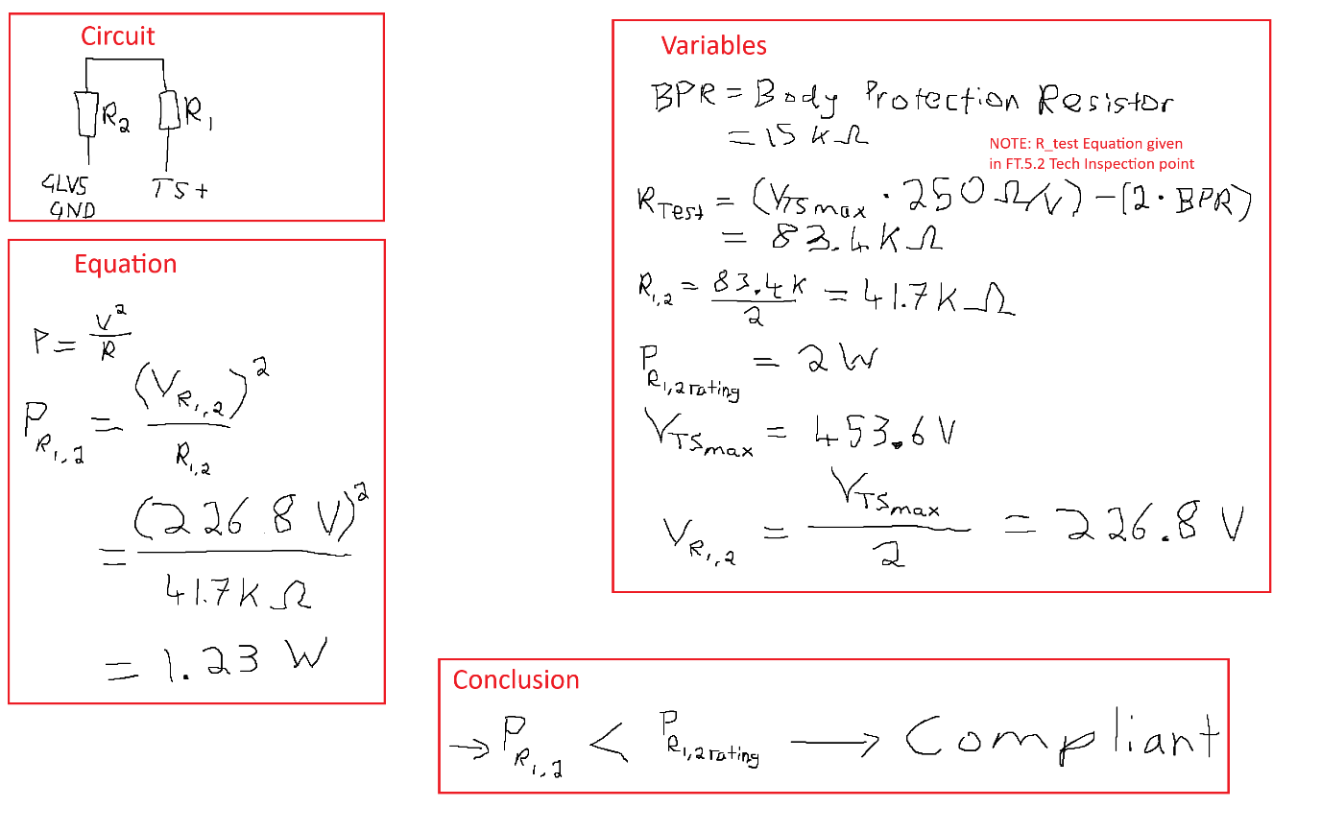
Figure 25. Proof of IMD Test Resistor Power Requirement Compliance

Parc fermé
At the end of the Endurance event, the car enters Parc fermé, regardless of if it successfully finishes the event or not.
In 2025 the structure of Parc fermé was:
- Push bar the car into the Parc fermé bay.
- All members of the team had to leave the bay and wait approximately 15 minutes.
- Once 15 minutes had passed, the Electrical Safety Officer (ESO) (the author), was the only one allowed in the bay.
- The Scrutineers would inspect:
  - IMD resistor test
  - APPS plausibility test
  - Remove Energy Meter from car
Once the above had been completed, the car could then be removed from the bay and be officially done with competition and laid to rest.
The Scrutineers commented on the team’s efficiency during Parc fermé.
In 2024, the Scrutineers also asked to see the thermal strip in the Accumulator, for this the Accumulator had to be removed from the car and the viewing hatch removed (shown in Figure 13. Thermal strip viewing hatch). In 2025, they did not ask to see the thermal strip. The author asked if they wanted to, and they said no. The author then later overheard Scrutineers saying that they had forgotten to ask to see team’s thermal strips.

Team Leadership and Knowledge Transfer

2025 Mechatronic Team Structure and Member Roles
The structure of the Mechatronics team is largely dependent the number of Final Year Project (FYP) students that the team receives at the start of the year. After the FYP roles are determined, Directed Reading and Extra Curricular roles can be established.
In 2025 the final Mechatronics team was comprised of three (technically four if including parallel projects) FYP, three Directed Reading and one Extra Curricular student. Their roles are detailed below. Mechatronics team shown in
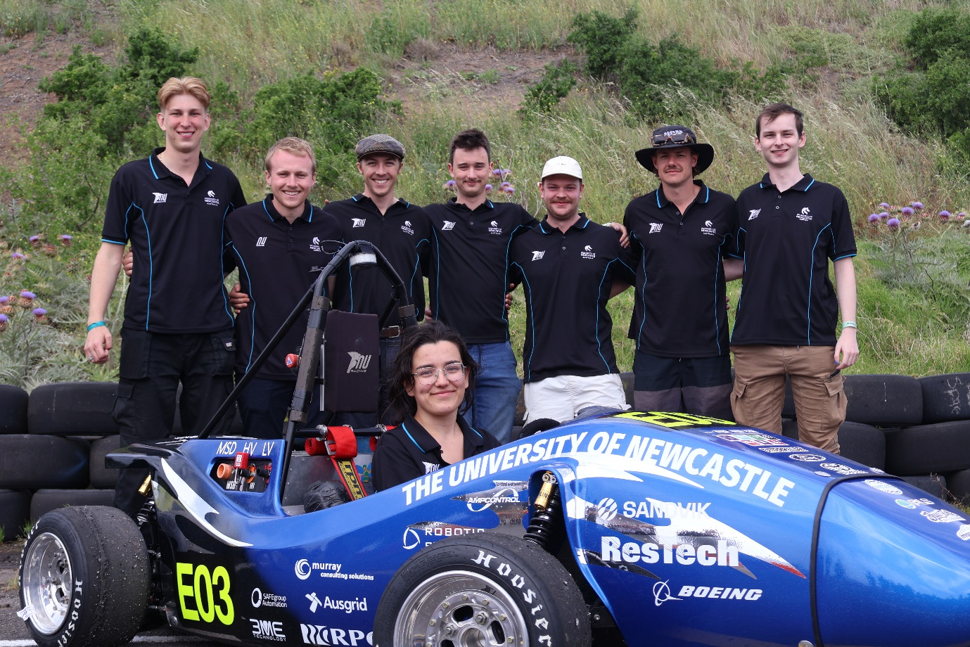
Figure 26. From left to right, Zak Lobko (Sem 1 Directed Reading), Samuel Connett (HV Powertrain), Oscar Rudman (Accumulator Electronics), the Author, Jayden Horvath (Autonomous Vehicle Development), Oliver Bunny (Data Engineer), Jayson Mills (Sem 1 Directed Reading), seated in car Mia Cosentino (Sem 2 Directed Reading), and Fletcher Cogoi (not pictured)

Data Engineer
The scope of this role was to increase the mediums of which data can be collected on the competition platform. As well as maintain the DBC of the car’s CAN Bus system. Specific tasks that the individual performed in 2025 can be found in Oliver Bunny’s report [13].

HV Powertrain Engineer
The scope of this role was to maintain the High Voltage (HV) Powertrain on the competition platform. As well as develop the validation capability of the dynamometer. Specific tasks that the individual performed in 2025 can be found in Samuel Connett’s report [7].

Accumulator Electronics Engineer
The scope of this role was to maintain the Accumulator electronics on the competition platform. As well as develop the electronics of the next generation of NU Racing’s Accumulator. Specific tasks that the individual performed in 2025 can be found in Oscar Rudman’s report [12].

Sem 1 ENGG3200, CEN PCB
Increase serviceability of Central Electronics Node (CEN). Specific tasks that the individual performed in 2025 can be found in Zak Lobko’s report [10].

Sem 1 ENGG3200, PEN & Breakout Board PCBs
Increase serviceability of Pedal Electronic Node (PEN), ensure compliance of Breakout Board PCBs, create an introduction to designing PCBs for NU Racing. Specific tasks that the individual performed in 2025 can be found in Jayson Mills’ reports [9] [18].

Sem 2 ENGG3200, HIP, BEN, LVD PCBs
Ensure compliance of Human Interface Panel (HIP) on NU25, make desired technical changes to BEN and LVD PCBs on AV.One. Specific tasks that the individual performed in 2025 can be found in Mia Cosentino’s reports [11] [19] [20].

Proposed 2026 Mechatronics Team Structure and Member Roles
While the final number of Mechatronics roles for 2026 is largely dependent on the number of members the team receives, below is a recommended list of roles for the 2026 team to consider.

Data Engineer
Continue development of data collection methods and validate sensors readings implemented in 2025

HV Powertrain Engineer
Continue to maintain HV Powertrain of competition platform, help Dynamometer Engineer implement inverter/motor tuning.

Dynamometer Engineer
Finish implementing the system to control and power the Dynamometer. Validate motor datasheet values, aid in Hub Motor development.

Accumulator Electronics Engineer
Implement Pouch Cell Accumulator into the competition platform. Validate improvements in capacity, power output, and PCB designs developed in 2025.

Directed Roles
The author does not have any recommendations for Directed Roles in 2026 but is certain that projects and tasks will fall out of the scoping process conducted at the start of the year.

Onboarding, Training, and Mentorship
Onboarding, training and mentoring of new members into NU Racing is a critical task. It is arguably the largest contributor to an efficient and remarkable team. It can be seen as the sole reason why NU Racing does so well compared to other University FSAE-A teams who have tripled the budget, double the manpower and exponentially more experience and knowledge.
In 2025, the author learnt many lessons on the onboarding, training and mentoring of individuals within the Mechatronics team. The author also received valuable mentorship from other NU Racing Leaders, and NU Teams academic and technical stuff.

Starter Projects
In 2025 and previous years, new FYP members are tasked with a 3-week starter project to give them a taste of what the role has to offer. It also serves as a way for the leadership team to gauge whether the individual is fit for the role.
In 2025 new FYP members were tasked with reading the last two years of reports from individuals who had done their role in the past. Two years was chosen as it was believed that this would give the individual a wide enough perspective of their role, without bogging them down with report reading. It is recommended that this idea is followed in future years.
Hard set deliverables and due dates play an important role in Starter Projects. They force the individual to work to a ‘deadline’, which has the benefit of showing the leadership team that the individual can either, get things done on time, or easily fall behind and let things go past their due date. If it is the latter, it can mean that this will be a repeated offence during the year.
The scope of work for a Starter Project should intentionally be fleshed out. So that it is as clear as possible to the individual what is expected of them. It also serves as a point to fall back on if they argue that the project was not well-defined after the due date has passed.
It can be hard to know how much work should be put into the scope. The author recommends trying your best to put as much work in that you believe is reasonable. This does require previous experience in the team. Otherwise consulting previous leaders, or even the individuals that were in the role, or role most similar in the previous year.
From the author’s perspective, the point of the Starter Projects is to serve three main points:
- Allow leaders to gauge if the individual is fit for the role. As well as if they are fit for the team as whole, regarding project timelines and dependencies.
- Give the individual as much of a summary as possible of what they will be doing within their FYP project. This involves letting the individual get their hands on as many things as possible, in a succinct manner, that makes sense for their project.
- To let the individual learn as many lessons as possible about the role. This is usually best done through failure. This ensures that the individual will be up-skilled as quickly as possible.
The author believes that by following this strategy, a Starter Project can be efficiently scoped.

FYP Starter Projects in 2025

Data Engineer
- Starter Project
  - Read Jackson’s report and Alec Chapman’s ENGG4200 Report
  - Read Nick Lyall’s report for amplifier circuit for wheel speed sensors
    - Read datasheet to see if this circuit is needed at higher revs, as Nick discovered this using a 3d printed mount to imitate a wheel
      - Failing datasheet retrieval, attempt to use Nick’s set up with a drill to see if higher revolutions can be achieved.
  - Read relevant rules from 2025 rules
  - Read through rule changes from 2024 to 2025
  - Mount wheel speed sensors (3d printed)
    - Design 3d printed mount to attach to potentially all 4 wheels of NU24
      - So that if project is finished, sensors can be easily tested
      - Do the front two first wheel speed sensors first
  - Creation of loom to plug into EXPANSION Board
    - Pinout of OEM connector researched
    - Pinout of new DT connector correct and able to interface with EXPANSION Board
  - Wheel speed sensor data is able to be read from MoTeC
    - Create 4 messages in NU25 DBC file for wheel speed sensors (one for each wheel), with correct scaling, offset, bit length and value range
    - Implement code for wheel speed sensors on the EXPANSION Board
      - With data from wheel speed sensor sent using the message from previous dot point
    - Configure MoTeC to read and display new message
  - Deliverable:
    - Front two-wheel speed sensors mounted
    - Working with the EXPANSION Board on CAN King and (hopefully) MoTeC

HV Powertrain Engineer
- Starter Project
  - Read and understand both Hayward’s and Dawso’s reports?
  - Implement any recommendations from Hayward’s report
    - Implement pack current derating at cell/pack temperatures over 50 degrees.
      - PEN code
        - Use either maxsegtemp or mincellvol/maxcellvolt
        - Derate from the 3 degrees under the max temperature rating of the VTC6
        - Limit current down to ~30A under high temperatures. Shut down all current above 60 degrees
  - Learn how to charge the car
  - Read relevant rules from 2025 rules
  - Read through rule changes from 2024 to 2025
  - Deliverable:
    - Current derate at high temperatures works as intended
      - Test to show it off could include having the max allowable temperature to be set to a low value (eg 30 degrees) and have a track day where the car is driven hard, if it works correctly, then current will be limited and cut out to the driver upon approaching and reaching the set limit
    - Know how to charge the car

Accumulator Electronics Engineer
- Starter Project
  - Read Daniel’s and Jedd’s report
  - Design and commission new AIL, breakout board mounting, implement change from Ivo’s report
  - Read relevant rules from 2025 rules
  - Read through rule changes from 2024 to 2025
  - Learn how to charge the car
  - Deliverable:
    - AIL ordered (with LTspice or breadboard test)
    - Know how to charge the car

Lessons Learnt by The Author During the Onboarding, Training and Mentoring Processes
- Do not treat people like trades people. They are bright and keen to learn engineers, who should be treated like engineers, they merely have a lack of institutional knowledge.
- Let and support people make mistakes. It is imperative that they are supported and allowed to make mistakes within their roles. As this is what helps the individual grow both technically and as a person. There is a critical balancing act at play here, due to the tight ship that NU Racing runs financially. Resulting in the leadership team needing to be acutely aware of sunk cost fallacy of projects.
- Be able to take criticism. From people in roles below, adjacent and above you.

Delegation, Progress Tracking, and Review Processes

Delegation
Delegation is a critically important role of the Mechatronics Department Lead Engineer. It is important to know when a task can be delegated or delt with by Department Lead.
NU Racing operates on a system level basis. With individuals assigned to those systems. Design and implementation are the primary aspects that get delegated to assignees. Tasks or issues that arise with that system also fall to the ownership of the assignees, depending on the situation (such as track day testing) and issue, it quickly requires more than the assignees of the system to fix it. Safety-critical changes, design review and quality control should remain assigned to the Department Lead.
As members evolve in their roles, it is critical that more delegation takes place, and they are trusted to conduct the work to a high standard.
When delegation is done correctly, the Department Lead should have time to ensure aspects such as competition submissions are on time and allow time for knowledge transfer documents and mediums to be developed, to improve internal processes, such as validation strategies and unit test procedures.
Though care should be taken as to not over delegate, as it will come across as laziness and the team will feel like you are purposely putting yourself above the rest of the team, and make them feel like you are undervaluing them.

Progress Tracking
Progress tracking of projects is a critical role of the Mechatronics Department Lead Engineer. As it allows the Department Lead to make informed decisions about timeline conflicts and member well-being.
In 2025, the author informally tracked progress through the year with short casual but technical catchups with individuals. When it came to high workload and crunch periods, the author saw it valuable to keep Tasks Lists of what individuals had to do by what date. This helped ensure that all project dependencies would line up correctly and hold individuals accountable if areas fell behind. There were moments in 2025 where keeping a Task List during high workload periods was difficult for the author, as often the author would be helping individuals get the work done on time. If possible, this should be done in a reduced capacity so that all aspects of the implemented solution are ready at the same time. To remain “high level” as one could put it.

Review Process
When tasks are delegated, there needs to be a method of review for the Department Lead to ensure the implementation is sound, compliant, and safe.
This can be in the form of manual review by the Department Lead, follow a chain of command through a peer review process, or requiring the individual implementing the change to create evidence that it is sound, compliant, and safe.

Knowledge Transfer and Documentation Outputs
The author used the few downtime moments to create knowledge transfer documents to help support this report, as well as to create other mediums for transferring the technical knowledge that the author has had the privilege to gain since second semester 2023.
These knowledge transfer outputs consist of:
- The Electrical System Overview. A summary of all the electrical connections on NU25. To give an overview of the complexity of the system, as well as to help with fault finding, and helping with individuals understanding of the Mechatronics systems of NU25. The author believes it is valuable to update and change the Electrical System Overview as the competition car changes year to year.
- MoTeC Zero to Hero. A summary of all the information about the wireless telemetry on the competition platform. This document was not completed in 2025, as the author ran out of time to complete it. It is highly recommended that when you feel as though you have learnt enough about the wireless telemetry (C125 programming, updating variables on the screen of the C125, how to set up the wireless telemetry at a track day, how to use either Dash Manager or Dash Editor) that you add this information into the Zero to Hero. In 2024 and 2025 it was arguably one of the least documented systems on the competition platform.
- How to Crimp NU25 HV Connectors. Being that the author decided to change the HV connectors on the NU25 to ones that the team had not used previously, the author saw it valuable to document the manufacturing process for it.

Risk Management and Lessons Learnt

Technical Risks and Mitigation Strategies
Entering the 2025 competition, while the car was extremely tested and the result of competition was extremely positive. The author had the following technical concerns about NU25 as the car entered its first dynamic event.
- BMS reliability. The highest concern for the author the entire 2025 competition. These faults were occurring during 2025 due to the smallest issues of bolts not being tight enough, or something rattling loose. The chance that something had rattled loose during transport between Newcastle and Melbourne, or during driving any of the dynamic events was far too high. Despite this concern, the author had trust in his Accumulator team. And the BMS remained active for the entire 2025 competition because of the trust and did not fault once. A massive achievement and relief, since from 2022, when the NU Racing first had a competitive EV car, the team has had Accumulator issues that caused the car to stop during AutoX and Endurance events at competition each year. And 2025 was the break of the curse!
  - The most contributing factor to not having the fault was the continual servicing of the Accumulator by the Accumulator Electronics and Mechanical Engineer throughout 2025.
- Inverter overcurrent fault. While it is not exactly known why this fault occurs yet, it is believed to occur due to two reasons. Reason 1 is from a high torque request, on a high grip surface, the Inverter could not hand the requested torque by the motor. Reason 2 is due to incorrect tuning between the motor and Inverter, causing incorrect current supply to the motor during rapid high torque request.
  - The fault occurred during two of the four Acceleration runs at competition. Causing the car to stop on track and the time for the run not being scored. The fault occurred due to a naïve implementation of torque ramping, which would create a step change after the driven axile would surpass a calculated speed of 30 Kph. From one torque to another. More information on the faults can be found in the Acceleration section of this report.
- During 2024, the team used dodgy and relatively cheaply made battery isolator switches for the Grounded Low Voltage Master Switch (GLVMS) and Tractive System Master Switch (TSMS). These switches would frequently have contacting issues, resulting in an unreliable method for turning on NU24’s LV and HV. An issue that carried through to the 2024 competition, where the LV switch failed an hour before the car was due to do it’s first Skid pad run. Luckily the team had a replacement and were able to replace it in time.
  - In 2025, the author opted to implement higher quality battery isolator switches, which proved to be beneficial as there was not a single failure of these switches during the running of NU25.
- Most of the LV looms on the car has been in use since 2023, most of which the author is unsure if correct sized wire AWG was used for the expected current passing through the wire. After an extremely high temperature track day, the CEN to Accumulator LV loom had burnt both sides of the loom on the DT connector at two of the DT pin locations. These pins supplied low voltage, high current to the Accumulator cooling fans, which would run at peak loads of approximately 24 A. After the uncountable amount of power cycles and kilometres that loom had endured, it eventually failed. This was swiftly replaced by a new loom the day it was found.
  - This highlights the potential for other looms on the competition platform that has been recycled year to year to randomly overheat and fail. Not all, but the ones carrying high current signals. Care should be taken to regularly inspect looms for damage.
- The E-stop located on the DEN (named the Dash E-stop) has had its mating contacts warn down over time. The author assumes due to incorrect use of the E-stop (pulling it out instead of twist pulling to release it). It was noticed to be warn down 4 days from competition, and the author had a handful ordered to the University that arrived after the team had left for competition. Luckily Mr Malcolm Sidney had not yet left, so was able to bring them down with him.
  - The replacement E-stops did not have to be used during the 2025 competition, but it should be noted as a potential point of failure for the shutdown system.
- The Accumulator saw two very late mechanical design implementations due compliance concerns. Namely the container and segment housings were replaced very close to competition. The author had integration concerns about these two late implementations, as there are usually things missed during design. Luckily the issues that occurred were easily fixable in the timespan. Details on these issues can be found in Ryan Bird’s FYP report [8].

Team and Workload Management Risks
The risks that the author had identified for mainly himself, but also for other team members of the Mechatronics team are detailed below.
- Burn out
- Overworking
- Timeline management
- FSAE-A rules
- Team Leader/Chief Engineer inconsistent participation in the team
- Constraints from Team Leader/Chief Engineer
- High voltage systems

Schedule and Delivery Risks
The author’s mindset to schedule and delivery risks and how to minimise them as best as possible was to follow the philosophy of fail early and fail cheaply. Failure is the key building block to a good engineer. Failing early allows time for design changes. Failing cheaply refers to both time and money cost. Due to the team’s small budget, failing cheaply is a key constraint.
From this, Mechatronic designs were able to have the most testing time of new systems on the competition platform. It gave the most time to implement changes, resulting in low risk from schedule and delivery timeframes.

Key Lessons Learnt
Arguably the largest risk that the author was met with personally was letting NU Racing consume his life. It became all I thought about, which was not healthy. I found it incredibly hard to tell myself to switch off when I needed to. Something I learnt from Dr Dylan Cuskelly during my performance review was that a way of switching off is by physically doing a task to turn your mind to something else. For me, I found this came in the form of ‘documenting’, writing down the concern at the forefront of my mind at the time helped me to not stress about this as much. But other methods include dedicating a specific shirt or item of clothing to a task. For example, wearing the NU Racing shirt only when doing NU Racing work and for nothing else. Or to distract yourself by exercising, playing video games, hanging out with loved ones. Something to physically separate yourself from your usual environment to force your brain to stop thinking.
Talk about things that are bugging you. About people’s behaviour or technical concerns about the car or how the team is running. Again, Dr Dylan Cuskelly is a valuable asset to have, who will drop everything he is doing to make sure that you are heard, and will give advice on the situation, or begin to put a plan in place to change things. It is never a sign of weakness to speak up, and the situation can literally only be better for it.

Project Outcomes and Performance Evaluation

Achievement of Project Objectives
- Did people do all the stuff we asked them to do

Assessment Against Success Measures
- Any success that occurred from Project Objectives and Success Criteria

Impact on Team Performance and Competition Readiness

Static Events Performance
Cover:
- Design Event
- Cost Event
- Any electrical-related questioning
Focus on:
- How mechatronic design choices were justified
- Whether documentation and validation held up
- Challenges raised by judges and how they were addressed

2025 Dynamic Events Performance
Focus on:
- Reliability and robustness of mechatronic systems
- Fault occurrence and recovery
- Thermal, electrical, or control limitations observed
- Whether performance matched expectations

Skid pad
No Mechatronic related issues were had during the Skid pad event. The two drivers did extremely well considering the conditions. The team placed 7th overall in this event

Acceleration
Acceleration has historically never been a dynamic event that NU Racing designed for, due to the sole fact that the team runs a single rear motor with very limited capability. NU Racing placed 2nd place in Acceleration, a result that the team is pleased with considering the conditions and that many other teams run hub motor designs in both two wheel and four-wheel configurations. Though the team’s fastest acceleration time was slower than 2024, the team showed their preparedness of successfully being on time and participating in the event. Something that a surprisingly amount of the big teams with more funding and people cannot say.
This being said, NU25 did have two Inverter faults causing the car to lose power during two of the four allowed Acceleration runs. Details listed below.
A screenshot of the stored MoTeC data can be seen in Figure 27. 2025 Acceleration Faults.
- The first fault occurred in the first driver’s second run with a torque step from 180 Nm to 180 Nm at the motor. The driver was instructed to put their foot down as quickly as possible, and the Inverter faulted before the car even moved.
- The second fault occurred in the second driver’s second run with a torque step from 160 Nm to 220 Nm, at a calculated speed of 20 Kph. The author and Chief Engineer were very sceptical of this implementation, but both saw the reward for the high-risk decision it was. Which turned out to be too high of a risk and the car faulted after the step change occurred.
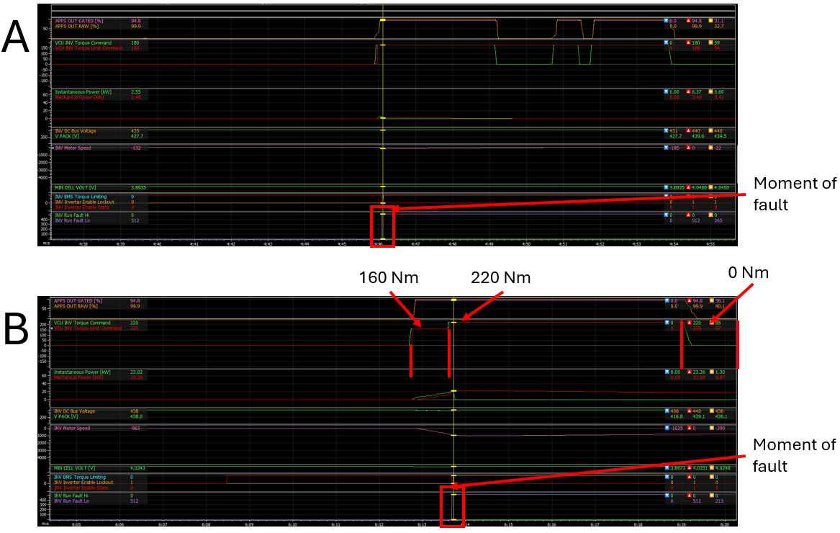
Figure 27. 2025 Acceleration Faults

AutoX
NU Racing has been chasing a first place in the AutoX event since 2023. This year, with all the effort that the team put in in 2025, the team finally accomplished this milestone. Obtaining the team’s first ever first place in a dynamic or static event at the FSAE-A competition.

Endurance & Efficiency
Being the event that halted the team’s success in 2023, the Endurance & Efficiency event has been one of most concern. Being the most weighted single event and the longest that the car must run throughout the entire competition, the team was rightfully concerned and stressed. Despite this, the team successfully finished the 22 km Endurance with no car stopping faults. The team placed 5th overall in Endurance, and 3rd overall in Efficiency, the highest placings the team has done in this event ever.
The only issue that arose was that the Accumulator was not fully charged to a pack voltage of 445 V (~95% SOC) before the event, it was left at 430 V after AutoX. The thought behind this being that regen braking would kick in earlier during the run, allowing for a higher efficiency score, and letting the driver gain a feel for regen braking earlier in their run rather than later.
This turned out to be a risky decision, as the car ended Endurance with a pack voltage of 341 V (~4.5% SOC). This meant that high current limiting was in place in the last few laps. Resulting in the car doing very slow lap times and impacting the overall performance in the remaining laps. The author is unsure if the finishing low pack voltage was due to the Accumulator not being fully charged, or that the track was purposely made to be extremely tight, reducing the number of high-speed sections. High speed sections allowing the most time for the Accumulator to regain charge.
A comparison of contributing factors can be found in *TODO: IN TEXT REFERENCE*
*TODO: MAKE UP A SUMMARY COMPARISON BETWEEN 2024 ENDURANCE AND 2025 ENDURANCE, WITH PACK VOLTAGE SUTFF THAT I HAVE IN A ONENOTE*

Reflection and Recommendations
In the Mechatronic Department Lead Engineer role, the author gained an incredible amount of how to be a better engineer. The author feels grateful for being able to have the opportunity to even been considered as a candidate for the role, and hope that he made an ever lasting impact on NU Racing and the people that he was lucky enough to work with.
An extensive summary of the lessons learnt and recommendations for future Mechatronic Department Lead Engineers, as well as potentially any future engineer are listed below. The author hopes that these learnings can help the reader better understand and prepare for the role.
Technical
- Phase cable retention in the phase cable cover in the power box
- Make i2 and T2 telemetry be able to stream on a local network at track days so that multiple laptops can be live data, and access logged data quicker (fault finding and driver training).
- Change port that either i2 or T2 accesses so that it doesn’t clash with dash manager and BMS orion 2 software
- Potentially move the BSPD to the HIP, wouldn’t need shielded wire on current sense signal, would mean more signals go to HIP, and larger connector
- Use the ESF to help make technical changes to the competition platform, being a calculator, it can quickly pick up on non-compliant design choices. 2025 it was used to see that the discharge resistor for the TS circuit was too large, causing too long of a discharge time. In 2024 it was used to see that the Accumulator insulation lining material was not compliant

Non-technical
- Be a leader, not a boss
- Communicate with other departments and leaders
- Keep a diary
- Fail early and fail cheaply
  - Test all new PCBs as soon as possible
  - Things will get missed, which will only be found in integration, be aware of it, but don’t be lazy during design
  - “A piece of advice the author received from Jye Hollier was that time spent fixing known issues from a prototype is far more valuable than time spent focusing on potential issues considered during design.” Lachlan Fisher [16].
- Put consistent work put into the project, there is not one major defining thing that makes someone good at this role, but the continued persistent drive to be better, and not to stay knocked down when something goes wrong.
  - Recommended books that explain this philosphy (both are a very good read):
    - The Slight Edge by Jeff Olson
    - Atomic Habits by James Clear
- Document detailing remaining things to do with projects (HIP PCB being ready but not enclosure, almost cut up HV lines without new HIP being ready)
- Scope out next mcha lead as early as possible, to help with the knowledge transfer process
- Vital aspects to consider when considering changes for systems are: (Systems-Level Engineering Perspective)
  - Safety
  - Compliance
  - Reliability
  - Inspect-ability (easy to show during Technical Inspection)
  - Integration effort (how much needs to change in order to implement the design)
- Create a document or process around how to validate a Mechatronic system
- Create a risk structure analysis, further detailed in the Risk-Based Decision Making section of this report
- Create a sort of leadership onboarding module, to help in the leadership handover section at the beginning of the year
  - Summary of all documents the team uses and why for example
- Don’t change stuff on the car less than 24 hours from a track day
- Be cynical during leaders meetings, talk about the shit before the good
- Make a ‘remaining manufacture’ list, keeps track of whats left to go for a design to get on the car
- Keep doing the ‘changes to nuxx’ before a track day

Reflection on the Mechatronic Department Lead Role
The role is an extremely mutli-faceted in many aspects, it ties in project management with high technical expertise and people managing. It is a major time commitment for it to be done well, but if willing, it is arguablly one of the quickest ways to upskill and learn about ones self technically and mentally at University.
It is the perfect role for an individual who is dedicated, enjoys learning, hungry for a challenge, and wants to improve themselves.

Recommendations for Future Mechatronic Leads
Below is a list of recommendations for specifically future Mechatronic Leads, to hopefully do better in the role than the author. They are both a mix of technical improvements and suggestions to help look after ones self during the wirlwind of a year. Please try to not stray from these suggestions, and remain honest with yourself if you do.
- Keep diary
- Use ESF
- Target low hanging fruit
- Talk to people
- Technical communication with mech lead
- Have hobbies outside of racing
- Try not let racing consume you
- Find the fun
- Find things you enjoy
- Make connections, make friends, talk shit, go outside, do activities that are both non-drinking and drinking related

Opportunities for Future System Improvement and Innovation
For 2026 and beyond, the author sees the following areas for the most beneficial tehcnical improvements to the competition platform. They aim to target low hanging fruit and bottlenecks of the Mechtronic system as a whole.
- Inverter and motor tuning
- Front wheel speed sensor and traction control tuning
- ESPs on car instead of teensys
- Pouch cell Accumulator
- Rear wheel hub motor implementation
- Custom bms
- Dyno
  - Test bed for future designs
    - PCBs
    - Cooling
    - Motor
    - Inverter

Conclusion
In conclusion, the author is incredibly lucky to have been given the opportunity to be NU Racing’s Mechatronic Department Lead Engineer. The author learnt many valuable lessons about himself that will stay with him far into his engineering career.
The author would like to thank the amazing team of 2025, without them none of the acheivements and accomplishments written about in this report would have possible.
Obtaining 3rd place in the FSAE-A competition is no small feat. It is a direct result of the blood, sweat and tears that NU Racing team members put into the year of 2025. It shows how commodary and the tight bond that NU Racing creates between team members absolutely smashes out the high budget, high resourced teams any day of the week.
Recommedations are listed in the Reflection and Recommendations section of this report. The author hopes that these are read and actioned in 2026 and even years beyond, as a way to not make the same mistakes and failings that the author made in 2025.
The author believes this report has shown the importance of this role to NU Racing, as well as what consistent, dedicated time put to a project can do.
Wrap up the main points of your work and explain how it all fits together. Summarise your recommendations for how to make this component/system and how to design and manufacture new versions of this in future.

References

[1] | SAE, “SAEA Formula SAE-A,” SAE, [Online]. Available: https://www.saea.com.au/formula-sae-a. [Accessed Janurary 2026].
[2] | J. Hayward, “Joshua_Hayward_FYP_Report_NU_Racing_Powertrain_Engineer,” 2024.
[3] | J. Boustany, “Jackson_Boustany_FYP_Report_Low-Voltage-Systems-and-Data-Acquisition,” 2024.
[4] | J. Lukes, “Jacob Lukes ENGG3200 CEN MOTHER board Report,” 2024.
[5] | J. Bush, “Jacob_Bush_CEN_BREAKOUT_BOARDS_2024,” 2024.
[6] | D. Iveson, “Daniel_Iveson_FYP_Report - Accumulator Electronics Engineer,” 2024.
[7] | S. Connett, “Samuel_Connett_FYP_Final_Report,” 2025.
[8] | R. Bird, “Accumulator Mechanical Engineer,” 2025.
[9] | J. Mills, “2025_PEN_Design_Report_Jayson_Mills_ENGG3200,” 2025.
[10] | Z. Lobko, “Zak Lobko - CEN Mother Board PCB - ENGG3200 Report,” 2025.
[11] | M. Cosentino, “2025_HIP_Design_Report_Mia_Cosentino_ENGG3200,” 2025.
[12] | O. Rudman, “Accumulator Electronics Engineer,” 2025.
[13] | O. Bunny, “Data Aquisition Engineer,” 2025.
[14] | J. Raj, “Brake Systems Engineer,” 2025.
[15] | T. Doubikin, “Powertrain & Cooling Engineer,” 2025.
[16] | L. Fisher, “2024 Chief Mechanical Engineer, Vehicle Dynamics, Cost Event, and Technical Inspection - Lachlan Fisher,” 2024.
[17] | Wikipedia, “Verification and validation,” Wikipedia, 19 December 2025. [Online]. Available: https://en.wikipedia.org/wiki/Verification_and_validation. [Accessed 6 January 2026].
[18] | J. Mills, “Jayson Mills - Zero-to-Hero How to Create a PCB For NU Racing,” 2025.
[19] | M. Cosentino, “2025_BEN_Design_Report_Mia_Cosentino_ENGG3200,” 2025.
[20] | M. Cosentino, “2025_LVD_Design_Report_Mia_Cosentino_ENGG3200,” 2025.

Appendices
TODO: If there’s anything else you wanted to add, this is where you put it.

Appendix A - Email Signature
Jacob Lukes
NU Racing - Mechatronic Department Leader
NU Teams is the official on-campus professional student engineering teams at The University of Newcastle
Bachelor of Electrical Engineering
Email: Jacob.Lukes@uon.edu.au
Web www.nuteams.org
The University of Newcastle Callaghan Campus, NSW 2308, Engineering Cl


A landscape page if you needed to put large sketches and images here.

Appendix B - NU25 Shutdown Circuit
A high-resolution version can be found in the NU Teams SharePoint, or in the Racing-NU25 Github Repository.
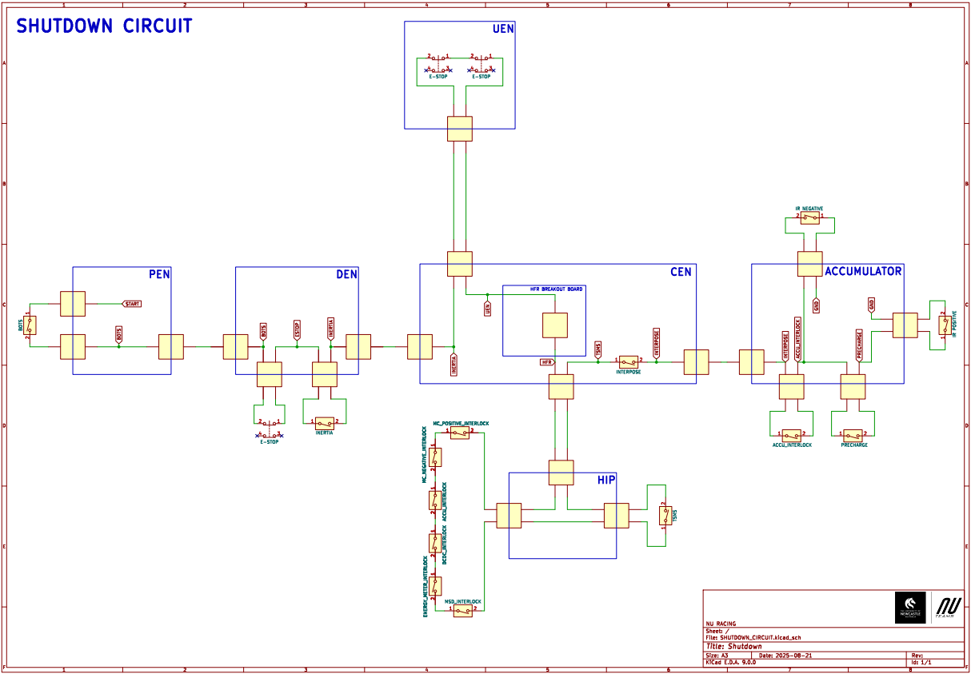

Appendix C - NU25 Electrical System Overview
*TODO: put overview here*
A high-resolution version can be found in the NU Teams SharePoint, or in the Racing-NU25 Github Repository.

Appendix D - 2025 Technical Inspection MCHA Bible
*TODO: PUT MCHA BIBLE HERE*

Just a portrait page after the landscape page if needed.

Appendix E – 2025 MCHA Systems Design Changes
*TODO: add 2025 MCHA Systems Design Changes*

